Fig. S1 Rheological properties for nanofluid of NiO-starch-NaOH-H₂O at φ₁=1.17%, different magnetic field and 298.15 K, S1a: Shear stress versus shear rate S1b: Shear viscosity versus shear rate.

S1a
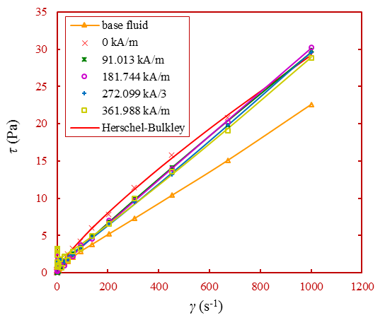
S1b
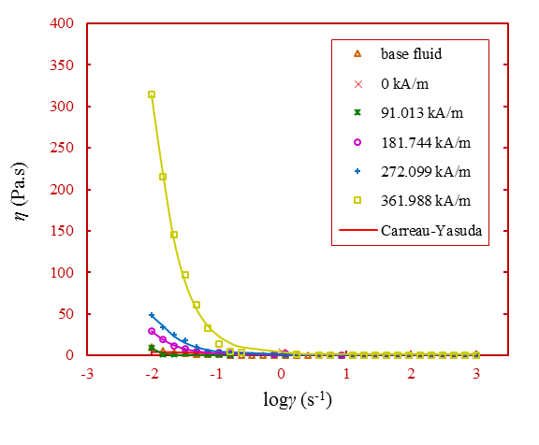

Fig. S2 Rheological properties for nanofluid of NiO-PEG400-PEG2000 at φ₁=1.35%, different magnetic field and 298.15 K, S2a: Shear stress versus shear rate S2b: Shear viscosity versus shear rate.

S2a
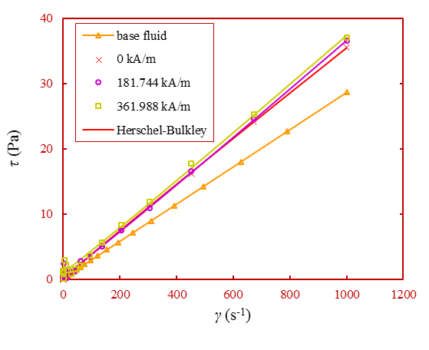
S2b
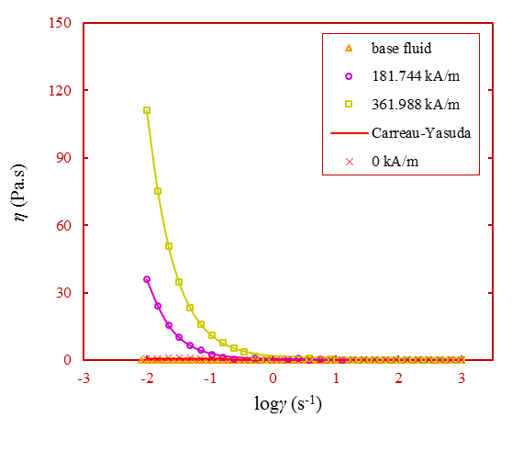
Fig. S3 Rheological properties for nanofluid of NiO-PEG400-PEG6000 at φ₁=1.35%, different magnetic field and 298.15 K, S3a: Shear stress versus shear rate S3b: Shear viscosity versus shear rate.
S3a
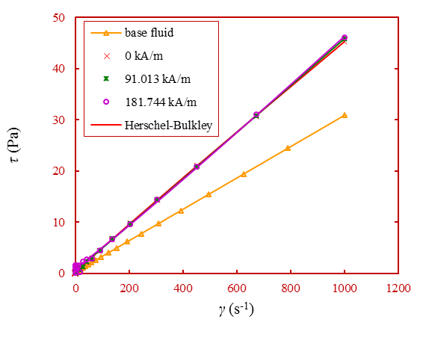
S3b
