Supporting information

Molecular insight into the mutual interactions of two transmembrane domains of Human Glycine Receptor (TM23-GlyR), with the lipid bilayers

Fatemeh Hamedi, Delara Mohammad-Aghaie*
Department of Chemistry, Shiraz University of Technology, Shiraz 71555-313, Iran

Email : d_aghaie@sutech.ac.ir

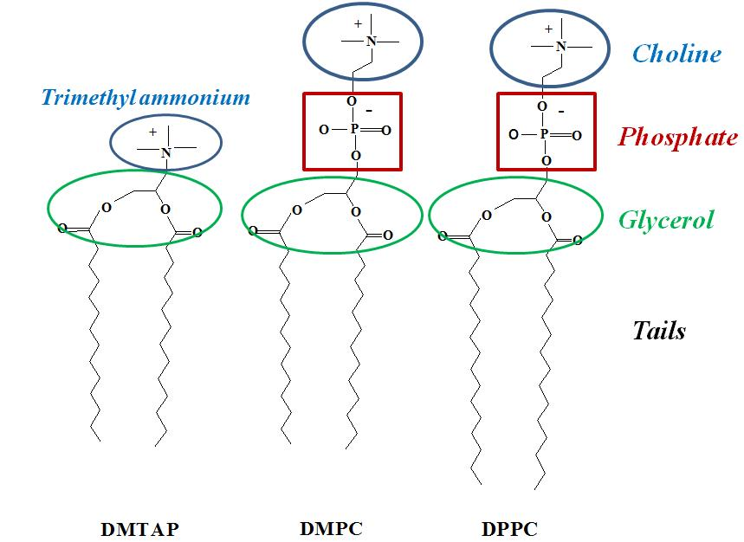
Figure S1. Chemical structures of the three studied lipids. Oxygen atoms in the phosphate and glycerol regions are the hydrogen bond acceptor sites.
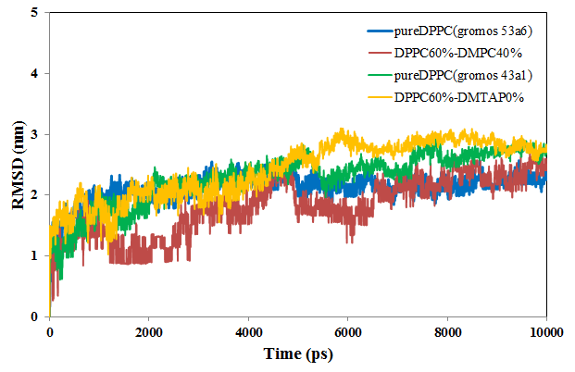
Figure S2. RMSD plots of DPPC molecules for systems, 1: pure DPPC (GROMOS 53A6), 2: pure DPPC (GROMOS 43A1), 3: (DPPC60%-DMPC40%) and 4: (DPPC60%-DMTAP40%).
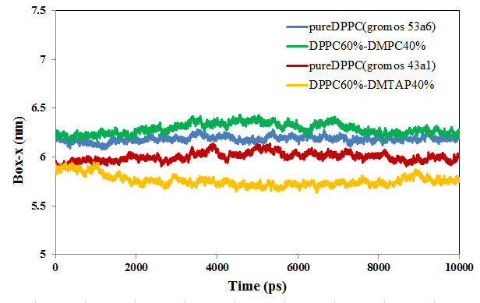
Figure S3. Box-x length of the simulation box for systems, 1: pure DPPC (GROMOS 53A6), 2: pure DPPC (GROMOS 43A1), 3: (DPPC60%-DMPC40%) and 4: (DPPC60%-DMTAP40%).

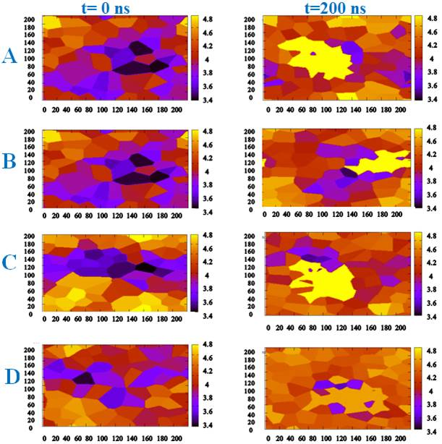
Figure S4. Membrane Thickness contour plots of protein-containing systems, A) System 5, Pure DPPC (GROMOS 53A6) + TM23-GlyR, B) System 6, Pure DPPC (GROMOS 43A1) + TM23-GlyR, C) System 7, (DPPC60%-DMPC40% + TM23-GlyR), D) System 8, (DPPC60%-DMTAP40% + TM23-GlyR), at the beginning (t=0 ns) and end (t=200 ns) of simulation runs. The legend shows bilayer thickness (nm), mapped to the corresponding colors.
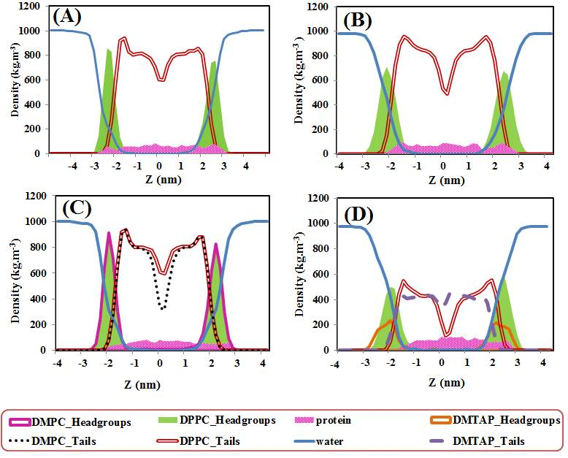
Figure S5. Density profiles of membrane components, along the membrane normal direction, obtained from the trajectories of protein containing systems, A) System 5, Pure DPPC (GROMOS 53A6) + TM23-GlyR, B) System 6, Pure DPPC (GROMOS 43A1) + TM23-GlyR, C) System 7, (DPPC60%-DMPC40%+TM23-GlyR), D) System 8, (DPPC60%-DMTAP40% + TM23-GlyR).

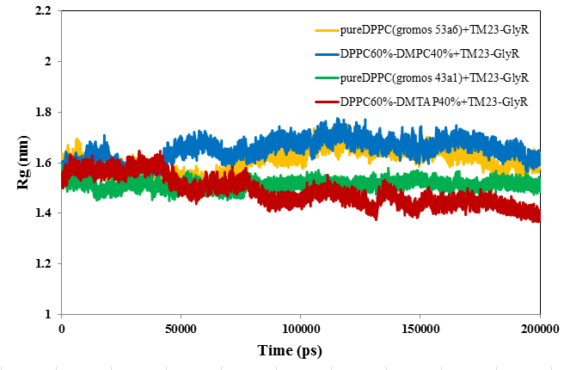
Figure S6. The Rg plots of TM23-GlyR membrane protein in systems: 5, [Pure DPPC (GROMOS 53A6) + TM23-GlyR], 6, [Pure DPPC (GROMOS 43A1) + TM23-GlyR], 7, [DPPC60%-DMPC40% + TM23-GlyR], and 8, [DPPC60%-DMTAP40% + TM23-GlyR], over 200 ns simulation time.

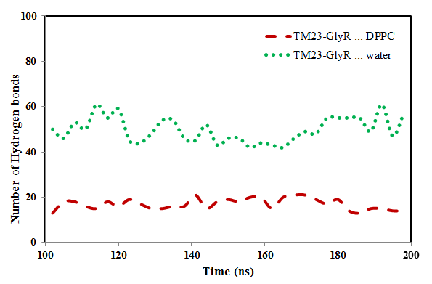
Figure S7. Number of hydrogen bonds of DPPC and water molecules with TM23-GlyR, in system 5, [pure DPPC (GROMOS 53A6) + TM23-GlyR] over last 100 ns.

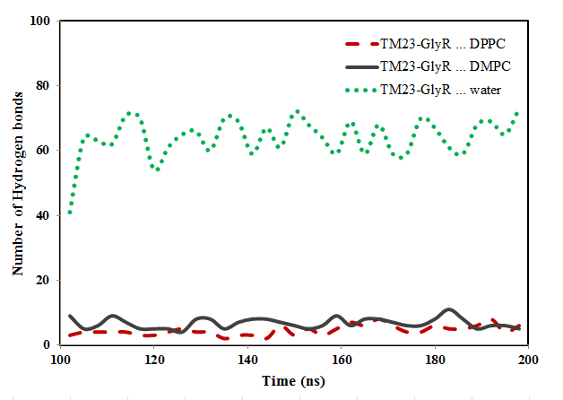
Figure S8. Number of hydrogen bonds of DPPC, DMPC and water molecules with TM23-GlyR, in system 7, [DPPC60%-DMPC40%+TM23-GlyR] over last 100 ns.

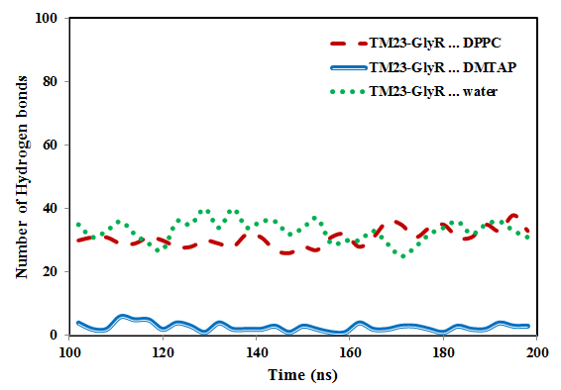
Figure S9. Number of hydrogen bonds of DPPC, DMTAP and water molecules with TM23-GlyR, in system 8, [DPPC60%-DMTAP40%+TM23-GlyR] over last 100 ns.

