Supplementry Information

Adsorption of an Azo Dye on Graphene Nanosheet: A Molecular Dynamics Simulation Study

Sara Samiee,ª Fatemeh Moosavi,ª Elaheh K. Goharshadi ^{,a,b,c}

ª Department of Chemistry, Faculty of Science, Ferdowsi University of Mashhad, Mashhad 9177948974, Iran
^{b} Center of Nano Research, Ferdowsi University of Mashhad, Mashhad 9177948974, Iran
^{c} Micro-Nano Technologies in Renewable Energies Center, Ferdowsi University of Mashhad, Mashhad 9177948974, Iran

Table S1. Structural parameters for the ground state of dye calculated at B3LYP/6-31+G* level of theory. Labels for atoms can be found in Fig. 1.
Bond length/Å |  | Bond angle/degree |  | Atomic charge/C
 | N₁-C₂ 1.41733  C₂-C₃ 1.40728  C₃-C₅ 1.39310  C₅-C₉ 1.39765  C₇-C₉ 1.39905  C₄-C₇ 1.39247  C₄-H₈ 1.08500  C₇-H₁₁ 1.08591  C₅-H₁₀ 1.08566  C₃-H₆ 1.08883  C₉-S₁₂ 1.80303  S₁₂-O₁₃ 1.47493  S₁₂-O₁₄ 1.47529  C₁₅-H₁₆ 1.09368  C₁₅-H₇₀ 1.09362  C₆₁-H₆₃ 1.09491  C₆₁-H₆₂ 1.09482  C₆₁-O₆₄ 1.43490  O₆₄-S₆₅ 1.65955  S₆₅-O₆₇ 1.50816  S₆₅-O₆₆ 1.50808  S₆₅-O₆₈ 1.45397  S₆₅-Na₆₉ 2.75558  N₁₇-C₂₅ 1.37570  C₂₅-C₂₆ 1.43689  C₂₆-S₅₆ 1.83220  S₅₆-O₅₈ 1.50366  O₅₉-S₅₆ 1.50507  S₅₆-O₅₇ 1.46738  S₅₆-Na₆₀ 2.74168  C₂₃-C₂₆ 1.38098  C₂₃-H₂₇ 1.08476  C₂₃-C₂₀ 1.41939  C₂₀-C₂₁ 1.40486  C₂₁-C₂₄ 1.38081  C₂₄-C₂₅ 1.43523  C₂₄-O₂₉ 1.35059  O₂₉-H₃₀ 0.98573  C₁₉-C₂₀ 1.42795  C₁₉-H₂₈ 1.08429  C₂₁-N₃₁ 1.46916  N₃₁-H₃₂ 1.03768  N₃₁-H₃₃ 1.03485  N₃₁-C₂₂ 1.50258  C₁₈-C₂₂ 1.41482  C₁₈-C₁₉ 1.37356  C₂₂-N₃₄ 1.31860  C₁₈-S₅₁ 1.83612  S₅₁-O₅₂ 1.46554  S₅₁-O₅₃ 1.50366  S₅₁-O₅₄ 1.50096  S₅₁-Na₅₅ 2.77007  N₃₄-N₃₅ 1.31709  N₃₅-C₃₆ 1.39544  C₃₆-C₃₇ 1.41066  C₃₇-H₄₀ 1.08605  C₃₇-C₃₉ 1.39001  C₃₉-H₄₄ 1.08594  C₃₉-C₄₃ 1.40128  C₄₁-C₄₃ 1.39782  C₃₈-C₄₁ 1.39375  C₃₆-C₃₈ 1.41669  C₃₈-H₄₂ 1.08784  C₄₁-H₄₅ 1.08633  C₄₃-S₄₆ 1.79700  S₄₆-O₄₇ 1.47651  S₄₆-O₄₈ 1.47448  S₄₆-C₄₉ 1.82519  C₄₉-H₅₀ 1.09362  C₄₉-H₈₀ 1.09389  C₄₉-C₇₁ 1.52603  C₇₁-H₇₃ 1.09460  C₇₁-H₇₂ 1.09315  C₇₁-O₇₄ 1.44374  O₇₄-S₇₅ 1.66105  S₇₅-O₇₆ 1.46111  H₇₅-O₇₈ 1.49882  S₇₅-O₇₇ 1.50840  S₇₅-Na₇₉ 2.73924 | O₆₆-S₆₅-O₆₇ 107.330  S₆₅-O₆₄-C₆₁ 116.616  C₆₁-C₁₅-S₁₂ 110.194  O₁₃-S₁₂-O₁₄ 120.811  C₁₅-S₁₂-C₉ 103.671  S₁₂-C₉-C₅ 119.271  C₉-C₅-C₃ 119.046  C₅-C₃-C₂ 120.440  C₃-C₂-C₄ 119.718  C₂-C₄-C₇ 119.975  C₄-C₇-C₉ 119.523  C₂-N₁-N₁₇ 113.284  N₁-N₁₇-C₂₅ 124.689  N₁₇-C₂₅-C₂₆ 134.623  C₂₅-C₂₆-S₅₆ 125.465  C₂₅-S₅₆-O₅₇ 105.353  C₂₅-S₅₆-O₅₈ 105.574  C₂₅-S₅₆-O₅₉ 104.553  O₅₇-S₅₆-O₅₈ 115.245  S₅₆₋C₂₆₋C₂₃ 114.311  C₂₆-C₂₃-C₂₀ 122.906  C₂₃-C₂₀-C₂₁ 116.706  C₂₀-C₂₁-C₂₄ 122.070  C₂₁-C₂₄-C₂₅ 121.406  C₂₁-C₂₄-O₂₉ 117.422  C₂₄-O₂₉-H₃₀ 105.397  C₂₄-C₂₁-N₃₁ 117.590  C₂₁-N₃₁-C₂₂ 116.110  N₃₁-C₂₂-C₁₈ 118.003  C₂₂-C₁₈-C₁₉ 122.513  C₂₂-C₁₈-S₅₁ 118.809  C₁₈-S₅₁-O₅₃ 103.156  O₅₄-S₅₁-O₅₂ 116.518  C₂₂-N₃₄-N₃₅ 115.981  N₃₄-N₃₅-C₃₆ 113.205  N₃₅-C₃₆-C₃₈ 123.407  N₃₅-C₃₆-C₃₇ 117.801  C₃₆-C₃₇-C₃₉ 120.680  C₃₇-C₃₉-C₄₃ 119.631  C₃₉-C₄₁-S₄₆ 119.788  C₄₃-S₄₆-O₄₇ 107.567  C₄₃-S₄₆-O₄₈ 107.911  C₄₃-S₄₆-C₄₉ 103.960  S₄₆-C₄₉-C₇₁ 110.916  C₄₉-C₇₁-O₇₄ 106.684  C₇₁-O₇₄-S₇₅ 115.908  O₇₄-S₇₅-O₇₈ 101.210  O₇₄-S₇₅-O₇₆ 107.420  O₇₆-S₇₅-O₇₇ 115.503 |  | N₁ 0.40734  C₂ -1.09882  C₃ 0.23643  C₄ -0.07080  C₅ 0.69881  H₆ 0.19453  C₇ -0.14526  H₈ 0.21103  C₉ -1.04359  H₁₀ 0.23398  H₁₁ 0.23635  S₁₂ 1.36162  O₁₃ -0.50000  O₁₄ -0.49089  C₁₅ -0.55978  H₁₆ 0.27102  N₁₇ -0.71670  C₁₈ -0.53191  C₁₉ -0.07785  C₂₀ 1.97315  C₂₁ -1.26422  C₂₂ -0.83357  C₂₃ 0.16533  C₂₄ -0.09788  C₂₅ -0.28207  C₂₆ -0.55282  H₂₇ 0.26188  H₂₈ 0.25945  O₂₉ -0.60141  H₃₀ 0.56381  N₃₁ -1.24949  H₃₂ 0.54129  H₃₃ 0.56539  N₃₄ 0.22046  N₃₅ -0.35943  C₃₆ -0.86621  C₃₇ -0.34638  C₃₈ 0.55088  C₃₉ 0.12367  H₄₀ 0.19880  C₄₁ -0.01290  H₄₂ 0.21953  C₄₃ -0.85496  H₄₄ 0.23001  H₄₅ 0.22770  S₄₆ 1.32418  O₄₇ -0.48525  O₄₈ -0.46699  C₄₉ -0.43603  H₅₀ 0.26657  S₅₁ 2.07519  O₅₂ -0.60938  O₅₃ -0.60155  O₅₄ -0.58017  Na₅₅ 0.80459  S₅₆ 1.80172  O₅₇ -0.58716  O₅₈ -0.60447  O₅₉ -0.64430  Na₆₀ 0.79003  C₆₁ -0.27311  H₆₂ 0.24311  H₆₃ 0.24076  O₆₄ -0.55051  S₆₅ 1.67519  O₆₆ -0.78238  O₆₇ -0.78207  O₆₈ -0.58446  Na₆₉ 0.86142  H₇₀ 0.27066  C₇₁ -0.41451  H₇₂ 0.26041  H₇₃ 0.24165  O₇₄ -0.58372  S₇₅ 1.83888  O₇₆ -0.60875  O₇₇ -0.80281  O₇₈ -0.78317  Na₇₉ 0.83048  H₈₀ 0.26044

Table S2 Structural parameters for the ground state of water calculated at B3LYP/6-31+G* level of theory.
Bond length/Å |  | Bond angle/degree |  | Atomic charge/C
 | O₁-H₂ 0.968930  O₁-H₃ 0.968930 | H₂-O₁-H₃ 105.505 |  | O₁ -0.927570  H₂ 0.463785  H₃ 0.463785

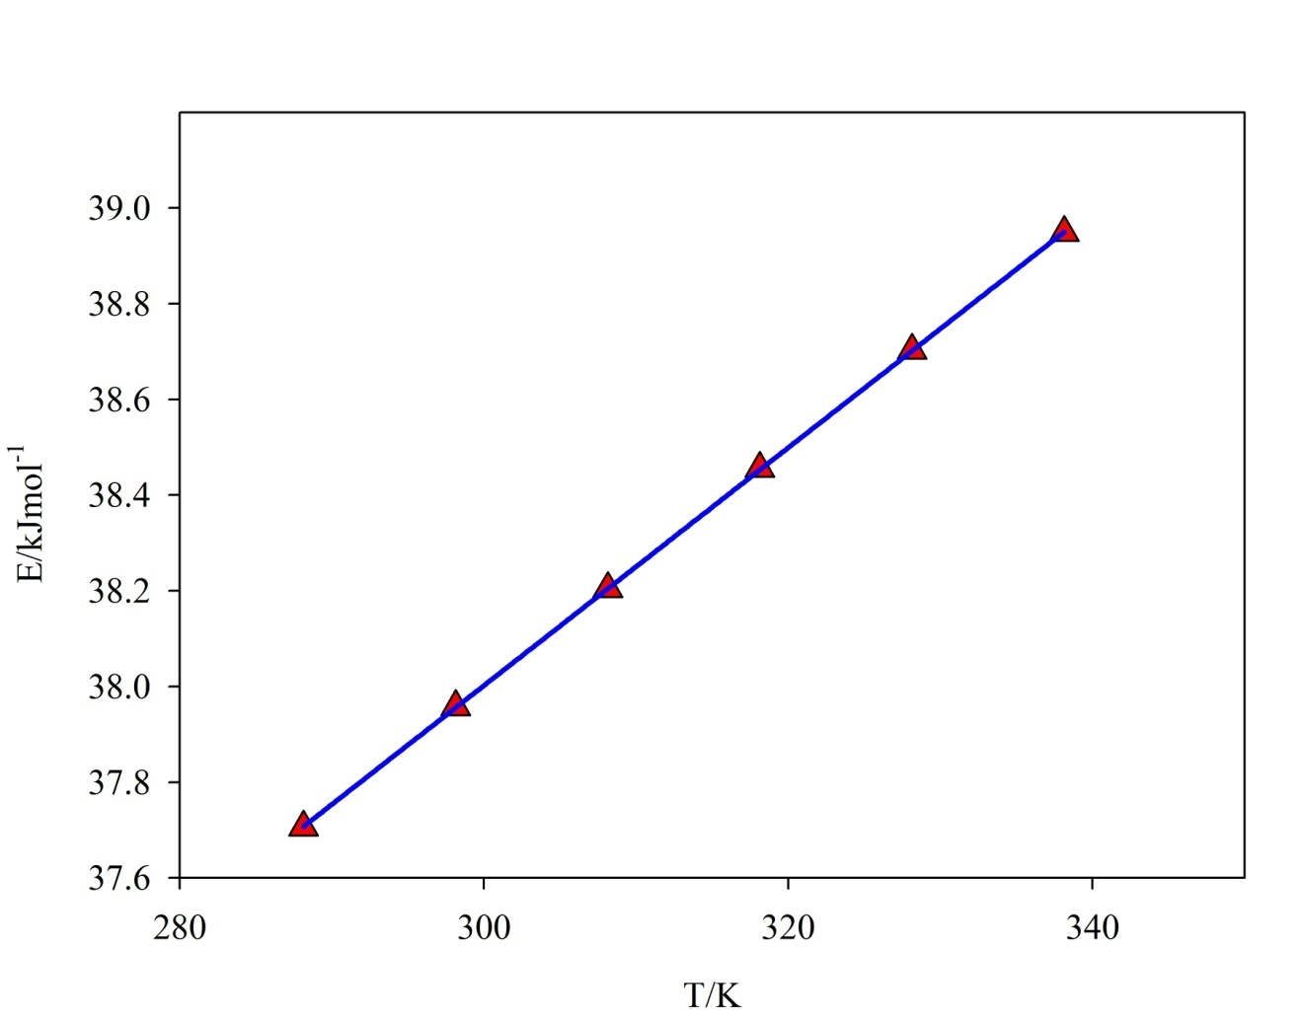

Fig. S1. The plot of total energy versus temperature for GNS used for calculation of the isochoric heat capacity.

Corresponding author. E-mail address: gohari@um.ac.ir (E. K. Goharshadi)

