Table S1 Node information associated with CART configured by recursive partitioning for 33anti-Alzheimer agents based on subset 3
Node | Splitting  Variable | Splitting  Value | Node  size | Node  Output | Role
1 | R3u | 2.23 | 25 | 1.240 | N
2 | Km | 0.428 | 16 | 1.417 | P
3 | Mor15u | 0.401 | 9 | 0.924 | N
4 | MATS1v | 0.000 | 8 | 1.259 | N
5 | TIE | 306.451 | 8 | 1.575 | N
6 | - | - | 3 | 0.651 | -
7 | Ss | 129.25 | 6 | 1.060 | N
8 | - | - | 1 | 0.974 | -
9 | MATS4p | -0.005 | 7 | 1.300 | P
10 | ZM2V | 343.111 | 6 | 1.527 | N
11 | - | - | 2 | 1.721 | -
12 | GNar | 2.249 | 4 | 1.116 | N
13 | - | - | 2 | 0.947 | -
14 | - | - | 4 | 1.261 | -
15 | - | - | 3 | 1.352 | -
16 | - | - | 3 | 1.564 | -
17 | - | - | 3 | 1.491 | -
18 | - | - | 3 | 1.085 | -
19 | - | - | 1 | 1.212 | -
Symbol “–” represents the leaf nodes without splitting variables and values. In the last column, “N” represents the negative effect of the corresponding splitting variable on the antimicrobial activity, and vice versa, “P” refers to the positive effect of the corresponding splitting variable on the antimicrobial activity.

Table S2 Symbols and definitions for the selected independent variables and descriptors involved in the CART, MLR and PCA methods
Symbols | Type | Description
MW | constitutional descriptors | molecular weight
AMW | constitutional descriptors | average molecular weight
Sv | constitutional descriptors | sum of atomic van der Waals volumes (scaled on Carbon atom)
Se | constitutional descriptors | sum of atomic Sanderson electronegativities (scaled on Carbon atom)
Sp | constitutional descriptors | sum of atomic polarizabilities (scaled on Carbon atom)
Ss | constitutional descriptors | sum of Kier-Hall electrotopological states
Mv | constitutional descriptors | mean atomic van der Waals volume (scaled on Carbon atom)
Me | constitutional descriptors | mean atomic Sanderson electronegativity (scaled on Carbon atom)
Mp | constitutional descriptors | mean atomic polarizability (scaled on Carbon atom)
Ms | constitutional descriptors | mean electrotopological state
nAT | constitutional descriptors | number of atoms
nSK | constitutional descriptors | number of non-H atoms
nBT | constitutional descriptors | number of bonds
nBO | constitutional descriptors | number of non-H bonds
nBM | constitutional descriptors | number of multiple bonds
SCBO | constitutional descriptors | sum of conventional bond orders (H-depleted)
nCIC | constitutional descriptors | number of rings
nCIR | constitutional descriptors | number of circuits
RBN | constitutional descriptors | number of rotatable bonds
RBF | constitutional descriptors | rotatable bond fraction
nDB | constitutional descriptors | number of double bonds
nAB | constitutional descriptors | number of aromatic bonds
nH | constitutional descriptors | number of Hydrogen atoms
nC | constitutional descriptors | number of Carbon atoms
Qnmax | charge descriptors | maximum negative charge
Qpos | charge descriptors | total positive charge
Qneg | charge descriptors | total negative charge
Qtot | charge descriptors | total absolute charge (electronic charge index - ECI)
Qmean | charge descriptors | mean absolute charge (charge polarization)
Q2 | charge descriptors | total squared charge
RPCG | charge descriptors | relative positive charge
RNCG | charge descriptors | relative negative charge
SPP | charge descriptors | subpolarity parameter
TE1 | charge descriptors | topographic electronic descriptor
TE2 | charge descriptors | topographic electronic descriptor (bond resctricted)
PCWTe | charge descriptors | partial charge weighted topological electronic charge
LDip | charge descriptors | local dipole index
SHP2 | Randic molecular profiles | average shape profile index of order 2
W3D | geometrical descriptors | 3D-Wiener index
J3D | geometrical descriptors | 3D-Balaban index
H3D | geometrical descriptors | 3D-Harary index
AGDD | geometrical descriptors | average geometric distance degree
DDI | geometrical descriptors | D/D index
ADDD | geometrical descriptors | average distance/distance degree
G1 | geometrical descriptors | gravitational index G1
G2 | geometrical descriptors | gravitational index G2 (bond-restricted)
RGyr | geometrical descriptors | radius of gyration (mass weighted)
SPAN | geometrical descriptors | span R
SPAM | geometrical descriptors | average span R
MEcc | geometrical descriptors | molecular eccentricity
SPH | geometrical descriptors | Spherosity
ASP | geometrical descriptors | Asphericity
FDI | geometrical descriptors | folding degree index
PJI3 | geometrical descriptors | 3D Petijean shape index
L/Bw | geometrical descriptors | length-to-breadth ratio by WHIM
Hy | empirical descriptors | hydrophilic factor
ARR | empirical descriptors | aromatic ratio
MR | Properties | Ghose-Crippen molar refractivity
PSA | Properties | fragment-based polar surface area
MLOGP | Properties | Moriguchioctanol-water partition coeff. (logP)
R3e | GETAWAY descriptors | R autocorrelation of lag 3 / weighted by atomic Sanderson electronegativities
Km | WHIM descriptors | K global shape index / weighted by atomic masses
Mor15u | 3D-MoRSE descriptors | 3D-MoRSE - signal 15 / unweighted
Lop | topological descriptors | Lopping centric index
GATS5e | 2D autocorrelations | Geary autocorrelation - lag 5 / weighted by atomic Sanderson electronegativities
E2m | WHIM descriptors | 2nd component accessibility directional WHIM index / weighted by atomic masses
Mor24e | 3D-MoRSE descriptors | 3D-MoRSE - signal 24 / weighted by atomic Sanderson electronegativities

Table S3 Rotated Component Matrix for five PCs
Symbols | Component
 | PC1 | PC2 | PC3 | PC4 | PC5
MW | 0.987
AMW |  | -0.675 |  | 0.663
Sv | 0.996
Se | 0.993
Sp | 0.995
Ss | 0.975
Mv |  | -0.914
Me |  |  |  | 0.949
Mp |  | -0.896
Ms | -0.578 |  |  | 0.729
nAT | 0.991
nSK | 0.999
nBT | 0.993
nBO | 0.999
nBM | 0.988
SCBO | 0.997
nCIC | 0.993
nCIR | 0.988
RBN |  | 0.765
RBF | -0.736 | 0.52
nDB |  |  |  |  | 0.774
nAB | 0.988
nH | 0.962
nC | 0.986
Qnmax |  |  | 0.922
Qpos | 0.985
Qneg | 0.985
Qtot | 0.985
Qmean |  | 0.78
Q2 | 0.976
RPCG | -0.957
RNCG | -0.955
SPP |  |  | 0.932
TE1 | 0.984
TE2 | 0.979
PCWTe | 0.978
LDip |  | 0.752
SHP2 | -0.989
W3D | 0.981
J3D | -0.913
H3D | 0.986
AGDD | 0.987
DDI | 0.984
ADDD | 0.993
G1 | 0.986
G2 | 0.998
RGyr | 0.969
SPAN | 0.81
SPAM | -0.96
MEcc | -0.8
SPH | -0.767 |  | -0.528
ASP | -0.863
FDI | -0.902
PJI3 |  |  | 0.815
L/Bw |  |  | 0.724
Hy |  |  |  | 0.954
MR | 0.993
PSA | 0.949
MLOGP |  | -0.755

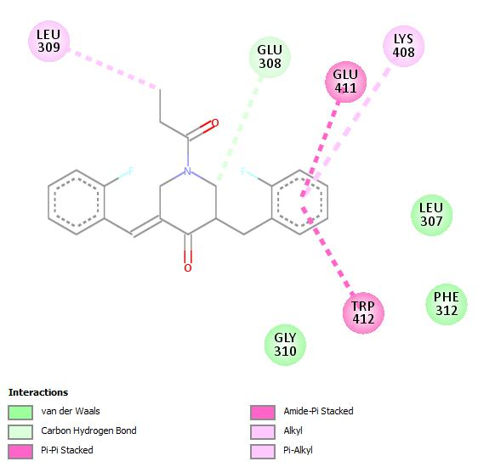
a
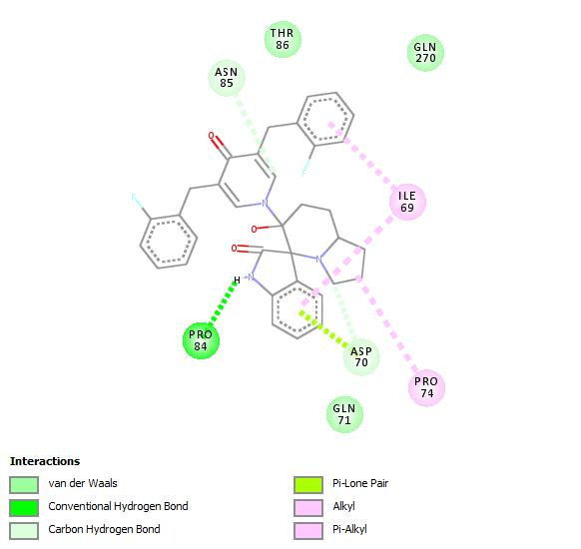
b
Fig. 1s Different interaction between the less active (5e) and the most active (8e) inhibitors with BuChe enzyme

