Figure 1: XRD PATTERN of graphite and graphene oxide

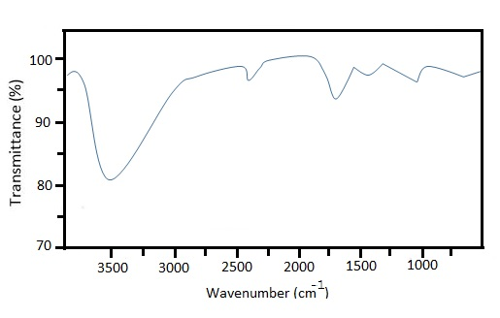
Figure 2: FTIR spectrum of graphene oxide
Figure 3: Figure 2: Effect of contact time and adsorbent dosage
Fig

FFFFigure 4A: Langmuir Isotherm
Figure 4B: Freundlich Isotherm

Figure 4C: Dubinin Isotherm

Figure 4D: Tempkin

Table 1: Graphical parameters of adsorption isotherm
 | R² | Slope | Intercept
Langmuir | 0.9545 | 2.0404 | 57.3366 | q_{m}  _{(mg/g)} | 0.0174 | K_{L}  _{(L/mg)} | 28.1006 | R_{L}  0.0023
Freudlich | 0.9937 | 1.9665 | 5.9086 | K_{F (mg/g)(L/mg)1/n} | 96.0505 | n | 0.9665 | 1/n  1.0346
Dubinin-Radushkevich | 0.9755 | 3.36X10⁻⁵ | 0.2656 | β  _{(mol}²_{kj}⁻²₎ | 3.36X10⁻⁵ | Qs  _{(mg/g)} | 1.3042
Temkin | 0.9768 | 1.9825 | 0.9365 | β  _{(KJ/mol)} | 1.9825 | K_{T} | 1.6038

Table 2: Graphical parameters of kinetic isotherm
 | R² | Slope | Intercept
Pseudo 1st | 0.9723 | 0.0185 | 0.8470 | qe_{(exp)(mg/g)} | 0.0721 | K₁ _{(g.mg}⁻¹_{min}⁻¹₎ | 0.0426 | qe _{(cal)(mg/g)} | 7.0307
Pseudo 2nd | 0.9958 | 2.2683 | 34.6211 | H_{(mg.g-1min}⁻¹₎ | 0.0288 | K_{2 (g.mg}⁻¹_{min}⁻¹₎ | 0.1486 | qe_{(cal) (mg/g)} | 0.4408
Elovich | 0.9789 | 0.0667 | 0.0650 | β _{(g.min-1)} | 0.0667 | α _{(mg.g.min}⁻¹₎ | 0.1767 | 1/ β | 14.9925
Intra particle  diffusion | 0.9567 | 0.0182 | 0.1825 | K_{id} _{(mg/g/min)} | 0.0182 | C _{(mg/g)} | 0.1825

Figure 5A: Pseudo 1st order

Figure 5B: pseudo 2nd order

Figure 5C: Elovich

Figure 5D: intra particle diffusion

Figure

F

