Supporting information
Molecular docking based on virtual screening, molecular dynamics, and Atoms in Molecules studies to identify the potential human epidermal receptor 2 intracellular domain inhibitors
Bahram Ghalami-Choobar^{a,b*}, Homa Moghadam^{b}
ªDepartment of Chemistry, Faculty of Science, University of Guilan, P.O. Box: 19141, Rasht, Iran
^{b}Department of Chemistry, University Campus 2, University of Guilan, Rasht, Iran
* Corresponding author. Tel.:+981333367262; Fax: +981333367262
E-mail address: B-Ghalami@guilan.ac.ir (B.Ghalami-Choobar)

Table S1: The obtained results for toxicity of compounds A -F
Number of ligand | ZINC database code | Ligand-Protein | E(kcal/mol) | TOX | MolDock Score
A(COM 1) | ZINC01398025 | 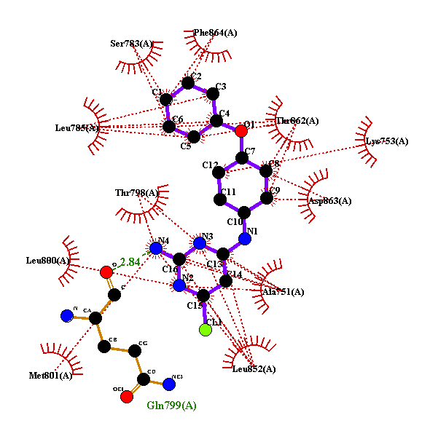 | -14.02 | 495mg/kg | -121.619
B | ZINC72240630 | 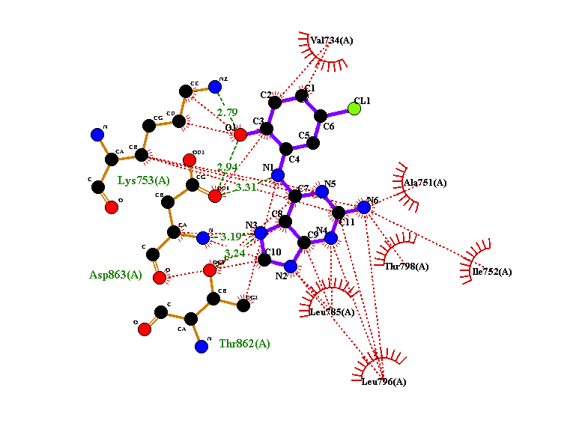 | -11.31 | 500mg/kg | -97.357
C | ZINC32097318 | 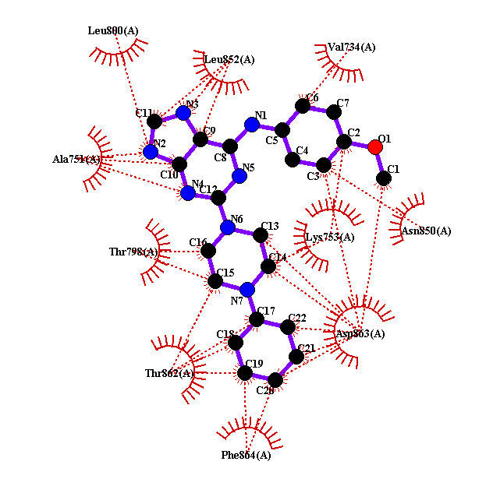 | -11.14 | 125mg/Kg | -95.119
D | ZINC49467748 | 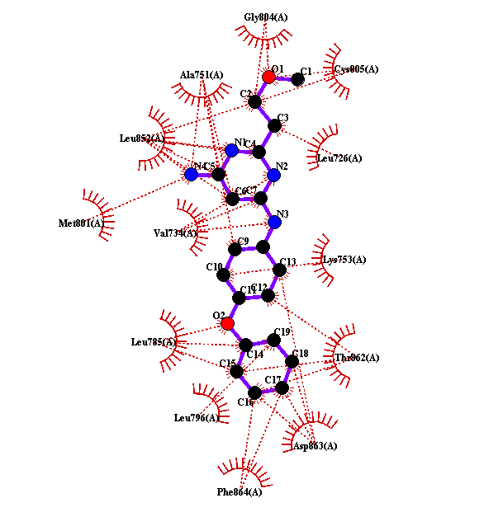 | -10.25 | 1000mg/kg | -84.028
E | ZINC40781039 | 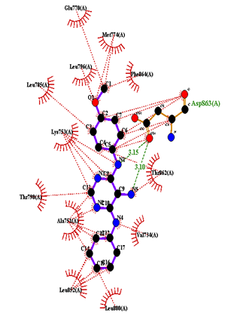 | -9.93 | 1600mg/kg | -83.703
F | template | pyrrolo[3,2-d]  pyrimidine analogue [33] | -10.27 | template

Table S2: Details of physico-chemical property filters available in FAF-Drugs
 | Rule of 3 | Rule of 5 | Drug-Like Soft ¹ | Lead-Like Soft ² | R.E.O.S | ZINC | CNS | Respiratory
MW | ≤ 300 | (≤ 500) | 100 - 600 | 150 - 400 | 200 - 500 | 60 - 600 | 135 - 582 | 240 - 520
logP | -3 to 3 | (≤ 5) | -3 to 6 | -3 to 4 | -5 to 5 | -4 to 6 | -0.2 to 6.1 | -2 to 4.7
HBA | ≤ 3 | (≤ 10) | ≤ 12 | ≤ 7 | ≤ 10 | ≤ 11 | ≤ 5 | -
HBD | ≤ 3 | (≤ 5) | ≤ 7 | ≤ 4 | ≤ 5 | ≤ 6 | ≤ 3 | -
HBonds | - | - | - | - | - | - | - | 6 - 12
tPSA | ≤ 60 | - | ≤ 180 | ≤ 160 | ≤ 150 | ≤ 150 | 3 - 118 | 51 - 135
Rotatable Bonds | ≤ 3 | - | ≤ 11 | ≤ 9 | ≤ 8 | ≤ 12 | - | 3 - 8
Rigid Bonds | - | - | ≤ 30 | ≤ 30 |  | ≤ 50
Rings | - | - | ≤ 6 | ≤ 4 | - | ≤ 7 | - | 1 - 5
MaxSizeSystemRing | - | - | ≤ 18 | ≤ 18 | - | ≤ 12 | - | -
Carbons | - | - | 3 - 35 | 3 - 35 | - | ≥ 3 | - | -
HeteroAtoms | - | - | 1 - 15 | 1 - 15 | - | ≥ 0 | - | -
H/C Ratio | - | - | 0.1 to 1.1 | 0.1 to 1.1 |  | ≤ 2.0 | - | -
Charges | - | - | ≤ 4 | ≤ 4 | - | ≤ 4 | - | -
TotalCharge | - | - | -4 to 4 | -4 to 4 | -4 to 4 | -4 to 4 | - | -
RO5 Violations | - | 2 | - | - | - | - | - | -
StereoCenters | - | - | - | ≤ 2 | - | - | - | -
References | 13 | 1 | 1,2,3,4,8 | 4,5,6,7 | 9 | 10 | 11 | 12

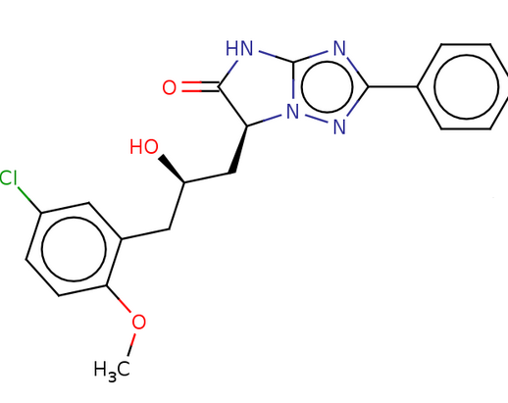
Figure S1: Structure 2D of ligand A
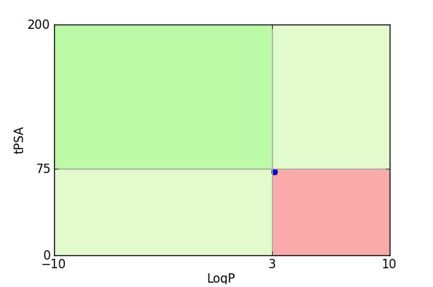
Figure S2: compounds located in the red square are likely to cause toxicity and experimental promiscuity PhysChem Filter Positioning of ligand A

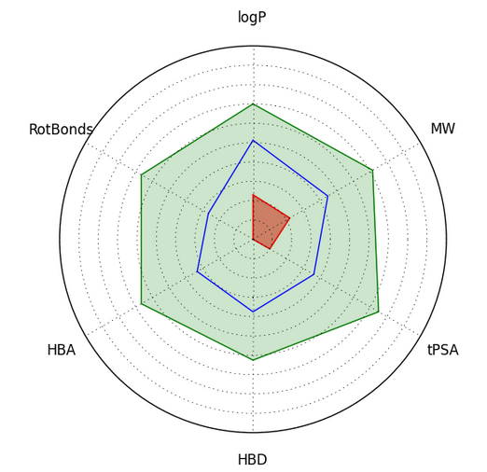

Figure S3: Compound values (blue line) should fall within the drug-like filter area. (Light blue)

Compound Complexity of ligand A

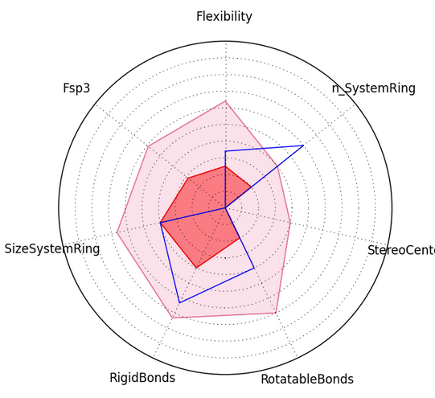
Figure S4: Compound values (blue line) superimposed on an oral library min and max ranges (pink and red) of ligand A
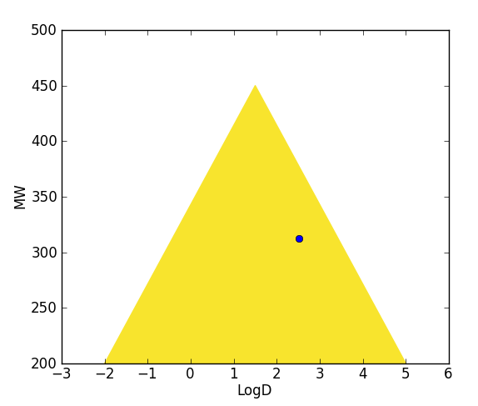
Figure S5: Compounds located in the yellow triangle are likely to have an optimal permeability (low clearance) and a good metabolic stability for ligand A

Table S3: Oral toxicity prediction results for input compond A
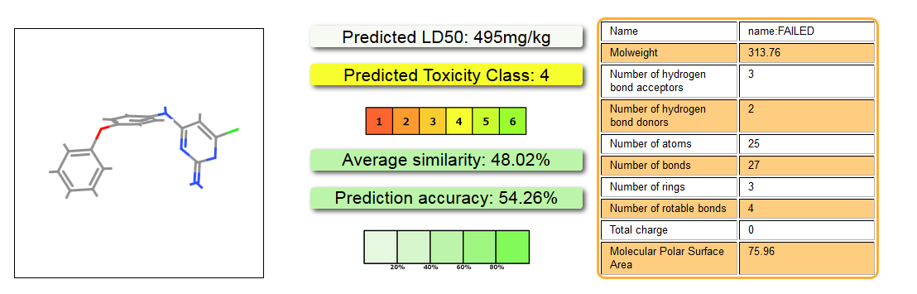

Table S4: FAF-Drugs rule for ligand A
D | ZIN_1_1
smiles | Clc1cc(Nc2ccc(Oc3ccccc3)  cc2)nc(=N)[nH]1
MW | 313.75
logP | 3.12
logD | 2.51
logSw | -3.86
tPSA | 72.63
RotatableBonds | 4
RigidBonds | 19
Flexibility | 0.17
HBD | 3
HBA | 5
HBD_HBA | 8
n_SystemRing | 3
MaxSizeSystemRing | 6
NumCharges | 1
TotalCharge | 1
n_HeavyAtoms | 22
n_carbon | 16
n_hetero | 6
ratioH_C | 0.38
n_LipinskiViolations | 0
Solubility | 6580.90
SolubilityForecastIndex | Reduced Solubility
VeberRule | Good
EganRule | Good
TrafficLights | 1
4_400 | good
3_75 | bad
Phospholipidosis | NonInducer
Fsp3 | 0.00
StereoCenters | 0
PPI_Friendly | Yes
State | Intermediate
iFilter | drug
Lilly | PASS

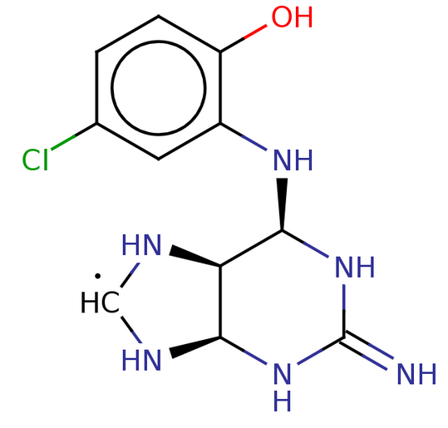
Figure S6: Structure 2D of ligand B

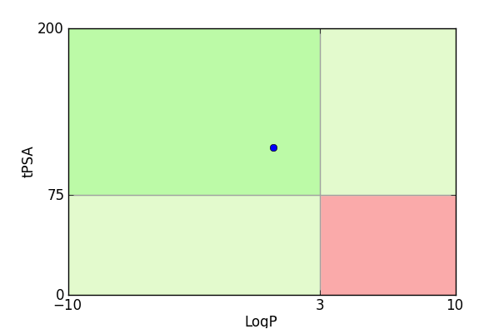
Figure S7: compounds located in the red square are likely to cause toxicity and experimental promiscuity of ligand B
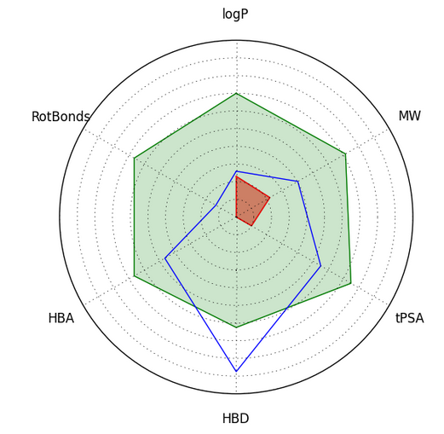
Figure S8: Compound values (blue line) should fall within the drug-like filter area. (Light blue) of ligand B

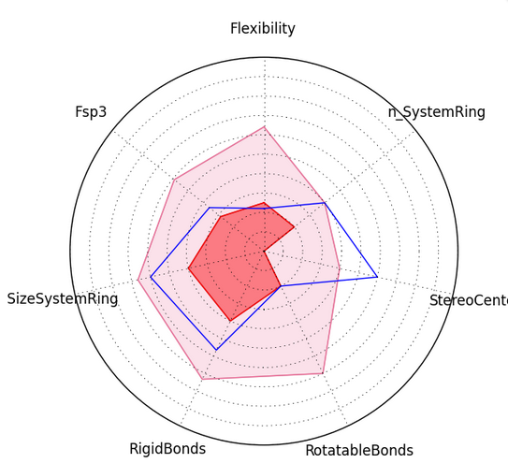
Figure S9: Compound values (blue line) superimposed on an oral library min and max ranges (pink and red) of ligand B
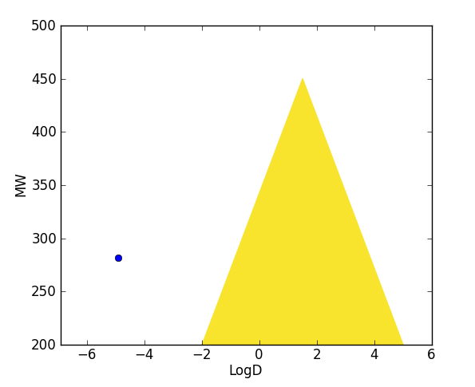
Figure S10: Compounds located in the yellow triangle are likely to have an optimal permeability (low clearance) and a good metabolic stability

Table S5: Oral toxicity prediction results for input compond B
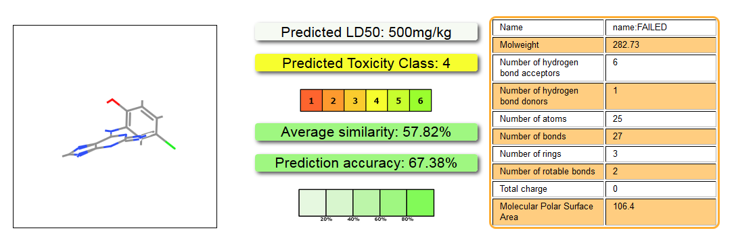

Table S6: FAF-Drugs rule for ligand B
 | ZIN_1_1
smiles | Oc1ccc(Cl)cc1N[C@H]1NC(=N)N[C@H]  2N[CH]N[C@@H]12
MW | 281.72
logP | 0.59
logD | -4.92
logSw | -1.96
tPSA | 110.55
RotatableBonds | 2
RigidBonds | 17
Flexibility | 0.11
HBD | 7
HBA | 7
HBD_HBA | 14
n_SystemRing | 2
MaxSizeSystemRing | 9
NumCharges | 2
TotalCharge | 2
n_HeavyAtoms | 19
n_carbon | 11
n_hetero | 8
ratioH_C | 0.73
n_LipinskiViolations | 1
Solubility | 39646.41
SolubilityForecastIndex | Good Solubility
VeberRule | Good
EganRule | Good
TrafficLights | 0
4_400 | good
3_75 | good
Phospholipidosis | NonInducer
Fsp3 | 0.36
StereoCenters | 3
PPI_Friendly | No
State | Rejected
iFilter | drug
Lilly | Lilly_TP1 abnormal_valenc

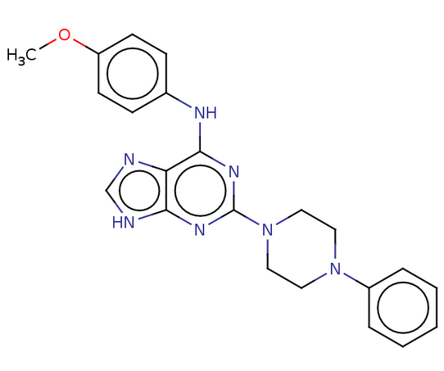
Figure s11 Structure 2D of ligand C

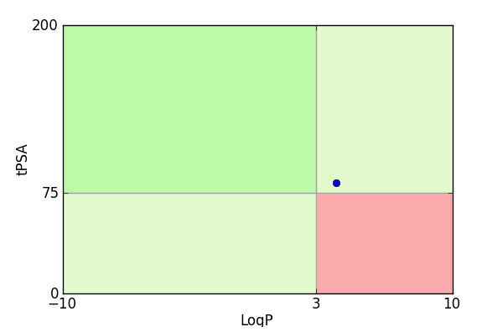
Figure S12: compounds located in the red square are likely to cause toxicity and experimental promiscuity of ligand C

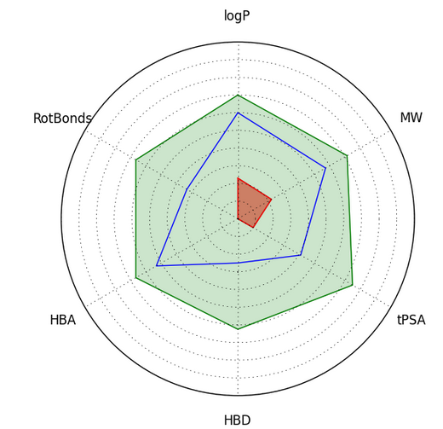

Figure S13: Compound values (blue line) should fall within the drug-like filter area. (Light blue) of ligand C
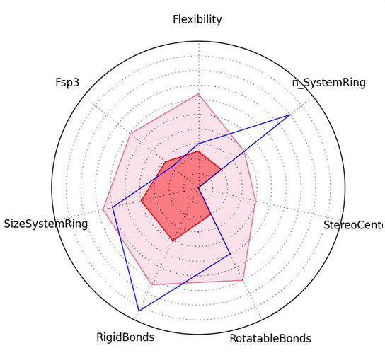
FigureS 14: Compound values (blue line) superimposed on an oral library min and max ranges (pink and red) of ligand C

Table 7: Oral toxicity prediction results for input compond C
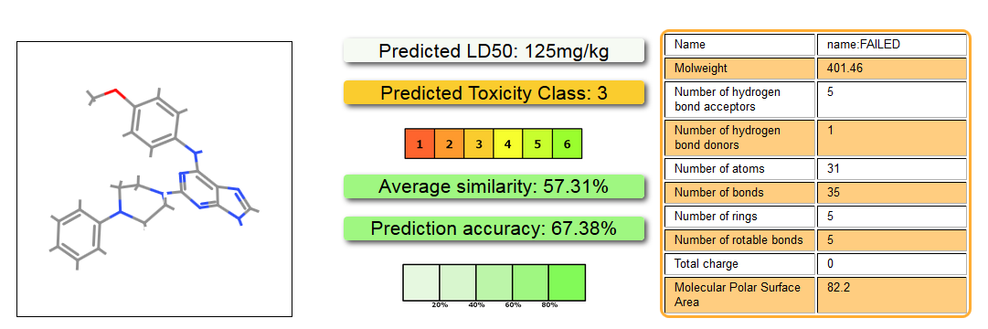
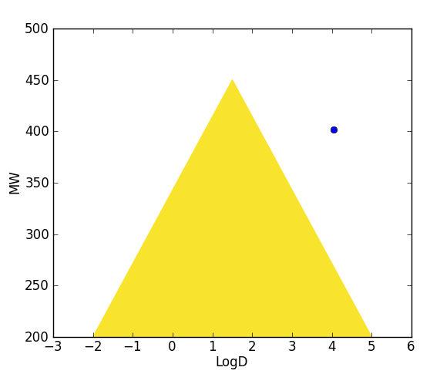
Figure 15: Compounds located in the yellow triangle are likely to have an optimal permeability (low clearance) and a good metabolic stability

Table s7: FAF-Drugs rule for ligand C
D | ZIN_1_1
smiles | COc1ccc(Nc2nc(nc3[nH]cnc23)N2CCN(CC2)c2ccccc2)cc1
MW | 401.46
logP | 4.00
logD | 4.05
logSw | -4.81
tPSA | 82.20
RotatableBonds | 5
RigidBonds | 28
Flexibility | 0.15
HBD | 2
HBA | 8
HBD_HBA | 10
n_SystemRing | 4
MaxSizeSystemRing | 9
NumCharges | 0
TotalCharge | 0
n_HeavyAtoms | 30
n_carbon | 22
n_hetero | 8
ratioH_C | 0.36
n_LipinskiViolations | 0
Solubility | 3263.60
SolubilityForecastIndex | Reduced Solubility
VeberRule | Good
EganRule | Good
TrafficLights | 2
4_400 | bad
3_75 | warning
Phospholipidosis | Inducer
Fsp3 | 0.23
StereoCenters | 0
PPI_Friendly | Yes
State  iFilter  Lilly | Accepted  Drug  PASS

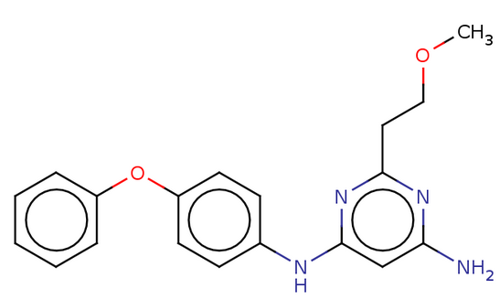
Figure s16: Structure 2D of ligand D

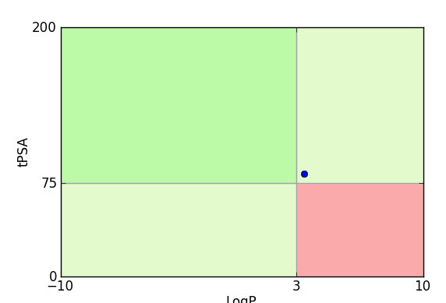

Figure s17: compounds located in the red square are likely to cause toxicity and experimental promiscuity of ligand D

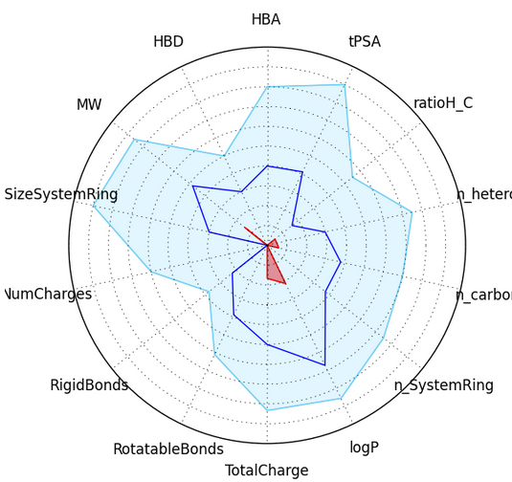
Figures 18: Compound values (blue line) should fall within the drug-like filter area. (Light blue) of ligand D

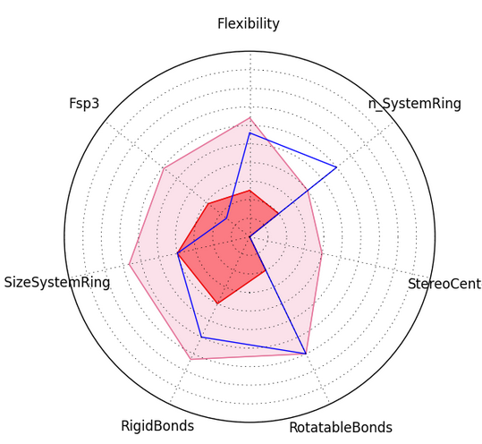
Figure s19: Compound values (blue line) superimposed on an oral library min and max ranges (pink and red) of ligand D

Table s8: Oral toxicity prediction results for input compond D

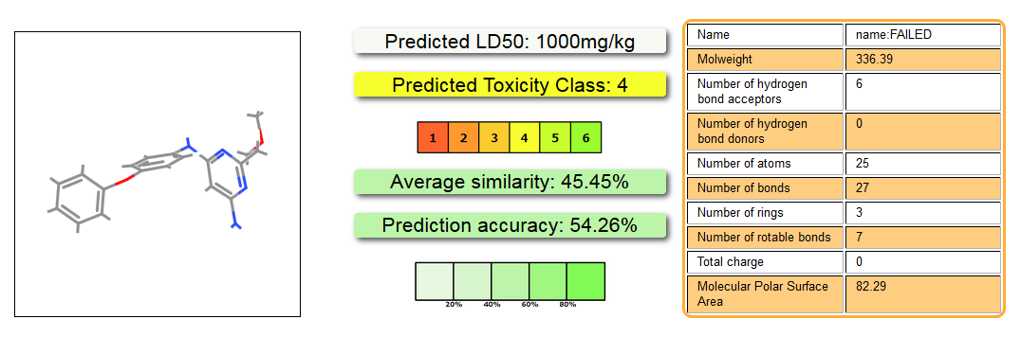

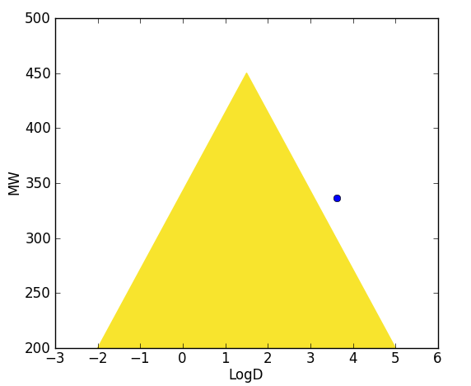
Figure s20: Compounds located in the yellow triangle are likely to have an optimal permeability (low clearance) and a good metabolic stability for ligand D

Table s9: FAF-Drugs rule for ligand D
ID | ZIN_1_1
smiles | COCCc1nc(N)cc(Nc2ccc  (Oc3ccccc3)cc2)n1
MW | 336.39
logP | 3.41
logD | 3.62
logSw | -3.91
tPSA | 82.29
RotatableBonds | 7
RigidBonds | 18
Flexibility | 0.28
HBD | 3
HBA | 6
HBD_HBA | 9
n_SystemRing | 3
MaxSizeSystemRing | 6
NumCharges | 0
TotalCharge | 0
n_HeavyAtoms | 25
n_carbon | 19
n_hetero | 6
ratioH_C | 0.32
n_LipinskiViolations | 0
Solubility | 6755.52
SolubilityForecastIndex | Reduced Solubility
VeberRule | Good
EganRule | Good
TrafficLights | 1
4_400 | good
3_75 | warning
Phospholipidosis | NonInducer
Fsp3 | 0.16
StereoCenters | 0
PPI_Friendly | Yes
State | Accepted
iFilter | drug
Lilly | PASS

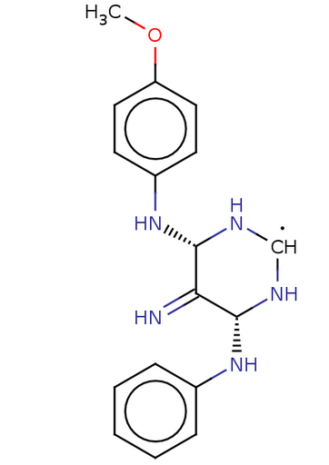

Figure s21: Structure 2D of ligand E

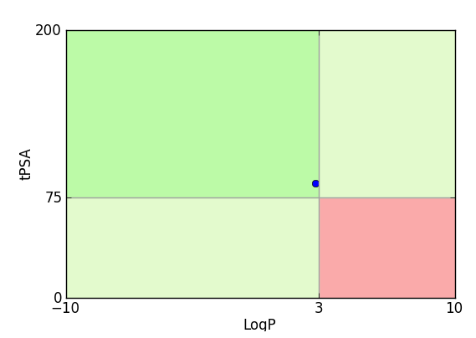

Figure s22:compounds located in the red square are likely to cause toxicity and experimental promiscuity of ligand E

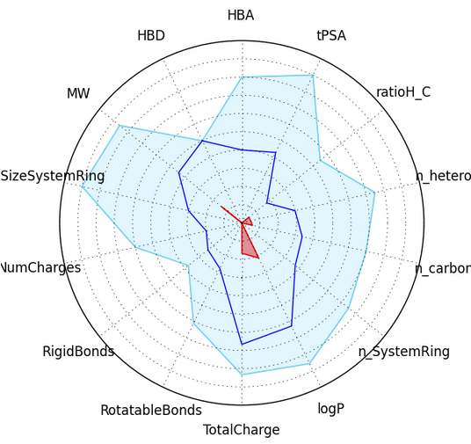
Figure s23: Compound values (blue line) should fall within the drug-like filter area. (Light blue) of ligand E

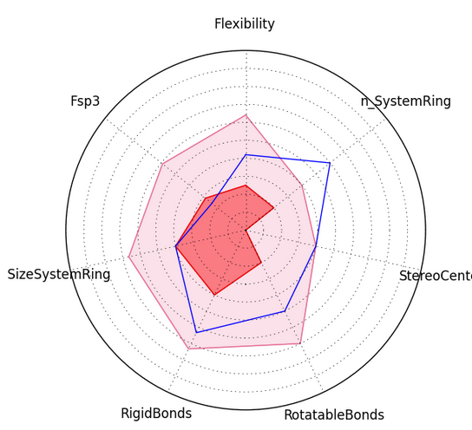
Figure s24: Compound values (blue line) superimposed on an oral library min and max ranges (pink and red) of ligand E

Table s10 Oral toxicity prediction results for input compond E

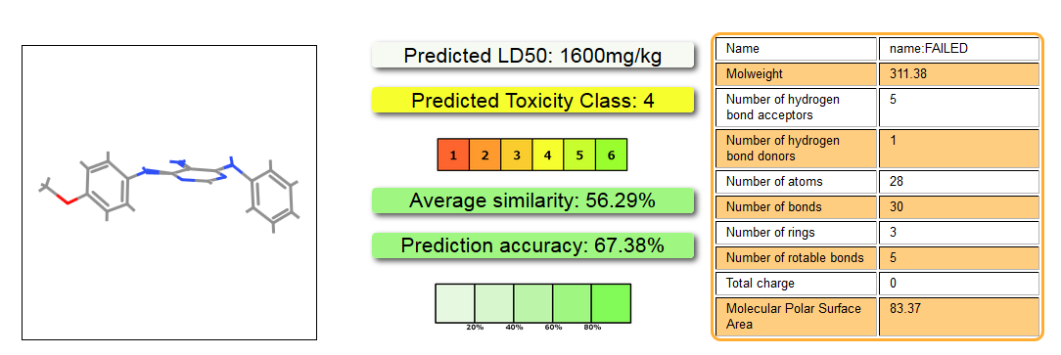

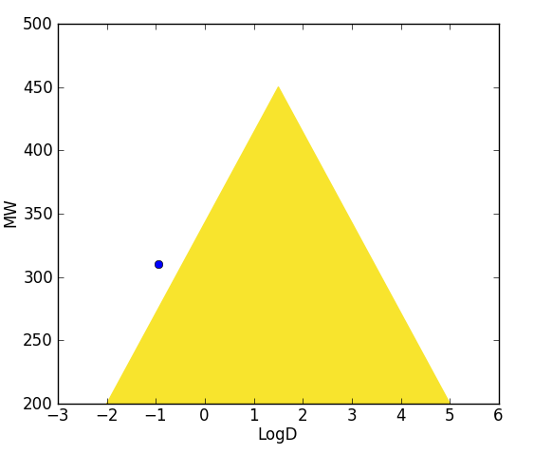
Figure s25: Compounds located in the yellow triangle are likely to have an optimal permeability (low clearance) and a good metabolic stability for ligand E

Table s11 FAF-Drugs rule for ligand E
ID | ZIN_1_1
smiles | COc1ccc(N[C@@H]2N[CH]N[  C@H](Nc3ccccc3)C2=N)cc1
MW | 310.37
logP | 2.80
logD | -0.94
logSw | -3.40
tPSA | 85.78
RotatableBonds | 5
RigidBonds | 19
Flexibility | 0.21
HBD | 5
HBA | 6
HBD_HBA | 11
n_SystemRing | 3
MaxSizeSystemRing | 6
NumCharges | 1
TotalCharge | 1
n_HeavyAtoms | 23
n_carbon | 17
n_hetero | 6
ratioH_C | 0.35
n_LipinskiViolations | 0
Solubility | 10308.29
SolubilityForecastIndex | Good Solubility
VeberRule | Good
EganRule | Good
TrafficLights | 0
4_400 | good
3_75 | good
Phospholipidosis | NonInducer
Fsp3 | 0.24
StereoCenters | 2
PPI_Friendly | No
State | Rejected
iFilter | drug
Lilly | Lilly_TP1 abnormal_valence
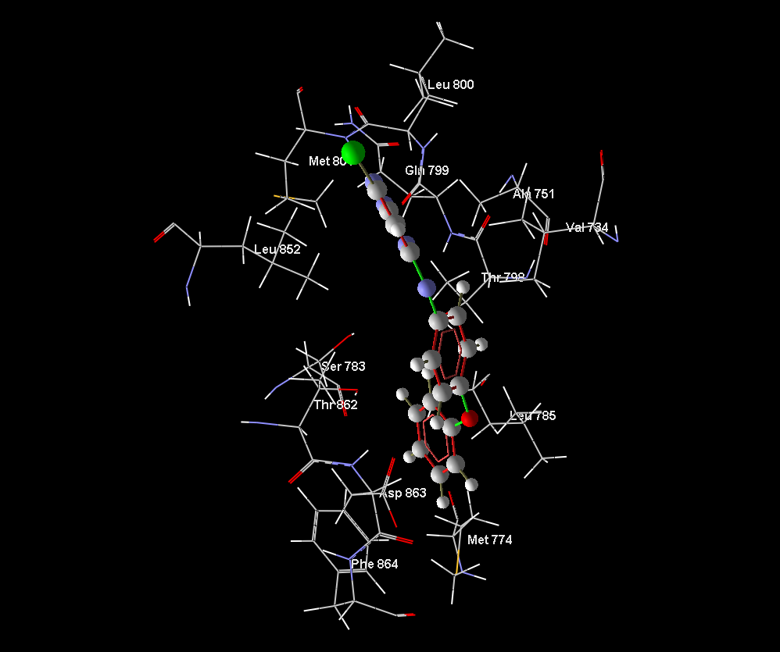
Figure s26: Amino acid residues located at active site of the COM 1

Supplementary validation of docking calculation of COM1

Schematic and tables below representations of the binding interactions between compound 1 and HER2 TK active site.
Regarding Ala751, Arg784, Asp863, Gln 798, Gly804, Ile752, Leu726, Leu785, Le796, , Leu800 , Leu852, Lys753, Met774, Met801, Phe864, Phe1004, Ser783, Thr798, Val 734, the biggest cavity that was found by mvd overlapped with the active sight predicted by auto dock vina. As such, these cavities were taken as the active sight in the models.
Also, the cavity with geometric position (X=12.03, Y=0.27, Z=29.73A) which was found by MVD in the predicted model, was confirmed by Autodock vina as substrate binding site.
Of course, two residue have very low energy traces and reported only by Molegro virtual docker (Gly804, Ile752).

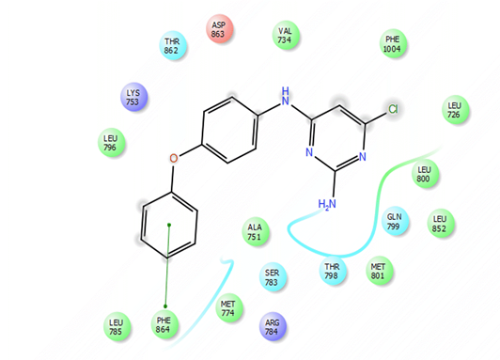
Figure s27 Docking results of COM1 that show residue and molecule contribution on the active site which obtained by Autodock Vina

Table s12 Atom energies of COM 1 obtained Molegro virtual docker
ID | Name | Total | EPair | EIntra
0 | C | -7.70775 | -8.8016 | 1.09385
1 | C | -6.17677 | -7.22384 | 1.04706
2 | C | -4.13518 | -5.07563 | 0.940444
3 | C | -2.62669 | -4.43449 | 1.8078
4 | C | -3.85609 | -5.97868 | 2.12258
5 | C | -7.9269 | -8.68292 | 0.756022
8 | O | -5.49717 | -4.23475 | -1.26242
9 | C | -2.77336 | -4.56174 | 1.78838
10 | C | -3.97299 | -5.10345 | 1.13046
11 | C | -4.61006 | -4.77063 | 0.160566
12 | C | -2.59994 | -4.35097 | 1.75103
13 | C | -4.35325 | -5.96912 | 1.61588
14 | C | -6.13292 | -6.40894 | 0.276022
17 | N | -4.60112 | -3.06241 | -1.53872
18 | C | -1.64979 | -3.18978 | 1.53999
19 | C | -1.8463 | -2.93382 | 1.08752
20 | C | -3.84786 | -5.05968 | 1.21181
21 | N | -5.41938 | -6.69352 | 1.27413
22 | C | -5.45609 | -6.41323 | 0.957142
23 | N | -0.45043 | -3.52049 | 3.07006
24 | N | -9.8694 | -8.74855 | -1.12085
27 | CL | -7.27333 | -6.40072 | -0.872607
0 | C | -7.70775 | -8.8016 | 1.09385
1 | C | -6.17677 | -7.22384 | 1.04706
2 | C | -4.13518 | -5.07563 | 0.940444
3 | C | -2.62669 | -4.43449 | 1.8078

Table s13 Docking results of COM1 that show residue and molecule contribution on the active site which obtained by Molegro virtual docker
Target | Residue | ID | E total | EPair
COM 1 | Ala | 751 | -8.42788 | -8.42788
COM 1 | Arg | 784 | -2.55212 | -2.55212
COM 1 | Asp | 863 | -10.4445 | -10.4445
COM 1 | Gln | 798 | -2.92751 | -2.92751
COM 1 | Gly | 804 | -1.09468 | -1.09468
COM 1 | Ile | 752 | -1.22436 | -1.22436
COM 1 | Leu | 726 | -1.34089 | -1.34089
COM 1 | Leu | 785 | -9.74985 | -9.74985
COM 1 | Leu | 796 | -5.34151 | -5.34151
COM 1 | Leu | 800 | -6.76172 | -6.76172
COM 1 | Leu | 852 | -10.4453 | -10.4453
COM 1 | Lys | 753 | -10.9037 | -10.9037
COM 1 | Met | 774 | -1.5502 | -1.5502
COM 1 | Met | 801 | -7.89442 | -7.89442
COM 1 | Phe | 864 | -5.66617 | -5.66617
COM 1 | Phe | 1004 | -1.34357 | -1.34357
COM 1 | Ser | 783 | -5.59438 | -5.59438
COM 1 | Thr | 798 | -9.69431 | -9.69431
COM 1 | Thr | 862 | -10.4476 | -10.4476
COM 1 | Val | 734 | -4.39876 | -4.39876

Supplementary validation of docking calculation of COM 2

Schematic and tables below representations of the binding interactions between compound 2 and HER2 TK active site.
Regarding Ala751, Asp863, Ile752, Leu726, Leu785, Leu796, Leu800 , Leu852, Lys753, Phe864, Thr798, Thr862, Val 734, Val797 the biggest cavity that was found by MVD overlapped with the active sight predicted by auto dock vina. As such, these cavities were taken as the active sight in the models.
Also, the cavity with geometric position (X=12.03, Y=0.27, Z=29.73A) which was found by MVD in the predicted model, was confirmed by Autodock vina as substrate binding site.
Of course, three residue have very low energies are reported only by Molegro virtual docker (Leu726, Leu800, Phe864).
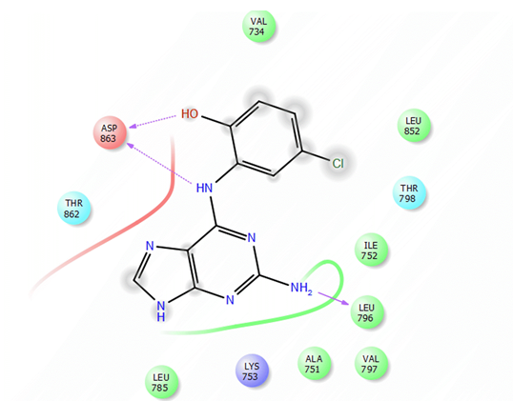
Figure s28 Docking results of COM2 that show residue and molecule contribution on the active site which obtained by Autodock Vina

Table s14 Atom energies of COM 2 obtained Molegro virtual docker
ID | Name | Total | E Pair | E Intra
0 | C | -1.69616 | -2.57246 | 0.876301
1 | C | -1.85633 | -2.68421 | 0.827883
2 | C | -3.56037 | -4.23547 | 0.675099
3 | C | -2.6166 | -4.3407 | 1.72409
4 | C | -1.42803 | -3.57142 | 2.14339
5 | C | -2.34294 | -2.99007 | 0.647139
6 | CL | -4.59395 | -3.69426 | -0.899688
8 | N | -5.0708 | -5.67543 | 0.604637
9 | C | -3.18722 | -4.27431 | 1.08709
10 | C | -4.07747 | -4.94319 | 0.865724
11 | C | -3.57867 | -4.79537 | 1.2167
12 | N | -4.00134 | -3.07672 | -0.924617
14 | C | -6.32235 | -5.33837 | -0.983974
15 | N | -7.47716 | -7.11491 | -0.362249
17 | N | -5.49213 | -6.37952 | 0.887387
18 | C | -8.43169 | -8.87139 | 0.439696
19 | N | -2.04088 | -4.59041 | 2.54952
20 | N | -12.3158 | -11.0069 | -1.3089
24 | O | -6.8556 | -7.20164 | 0.346041

Table s15 Docking results of COM2 that show residue and molecule contribution on the active site which obtained by Molegro virtual docker
Target | Residue | ID | E Total | EPair
COM 2 | Ala | 751 | -5.54884 | -5.54884
COM 2 | Asp | 863 | -17.4698 | -17.4698
COM 2 | Ile | 752 | -2.29892 | -2.29892
COM 2 | Leu | 726 | -0.42001 | -0.42001
COM 2 | Leu | 785 | -3.43031 | -3.43031
COM 2 | Leu | 796 | -12.9129 | -12.9129
COM 2 | Leu | 800 | -0.331085 | -0.331085
COM 2 | Leu | 852 | -5.38666 | -5.38666
COM 2 | Lys | 753 | -16.6065 | -16.6065
COM 2 | Phe | 864 | -0.811626 | -0.811626
COM 2 | Thr | 798 | -7.36196 | -7.36196
COM 2 | Thr | 862 | -11.7125 | -11.7125
COM 2 | Val | 734 | -6.52737 | -6.52737
COM 2 | Val | 797 | -2.93235 | -2.93235

Supplementary validation of docking calculation of COM 3

Schematic and tables below representations of the binding interactions between compound 3 and HER2 TK active site.
Regarding Ala751, Asp863,Arg849, Asn850,Leu726, Leu785, Leu796, Leu800 , Leu852, Lys753, Met774, Met801, Phe864, Phe1004, Phe731, Cys 805, Ser783, Thr798, Thr862, Val 734, the biggest cavity that was found by MVD overlapped with the active sight predicted by auto dock vina. As such, these cavities were taken as the active sight in the models.
Also, the cavity with geometric position (X=12.03, Y=0.27, Z=29.73A) which was found by MVD in the predicted model, was confirmed by Autodock vina as substrate binding site.
Of course, three residue have very low energies are reported only by the molecular (Leu726, Leu785, Leu796, Cys 805).

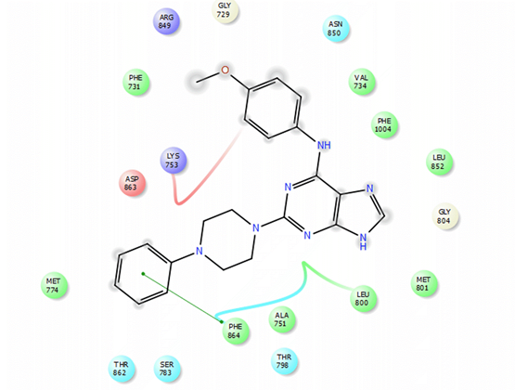
Figure s29 Docking results of COM3 that show residue and molecule contribution on the active site which obtained by Autodock Vina

Table s16 Atom energies of COM 3 obtained Molegro virtual docker
ID | Name | Total | EPair | EIntra
0 | C | -4.54747 | -5.30902 | 0.761547
1 | O | -3.89035 | -3.23116 | -0.659192
2 | C | -1.91412 | -2.87553 | 0.961409
3 | C | -1.74866 | -3.7485 | 1.99984
4 | C | -1.30473 | -3.00952 | 1.70478
5 | C | -0.125552 | -1.70538 | 1.57983
6 | C | -1.4801 | -1.87605 | 0.395944
7 | C | -1.66372 | -2.47089 | 0.807165
10 | N | -3.14665 | -1.85728 | -1.28937
11 | C | -1.59687 | -2.4134 | 0.816536
12 | C | -1.96647 | -2.67326 | 0.706792
13 | C | -2.36889 | -3.10029 | 0.731396
14 | N | -6.23331 | -5.21549 | -1.01781
16 | C | -7.04691 | -6.07258 | -0.974338
17 | N | -4.20416 | -3.84231 | -0.361844
19 | N | -1.6397 | -3.11804 | 1.47834
20 | C | -3.74478 | -3.47978 | -0.265003
21 | N | 1.25789 | -2.71807 | 3.97596
22 | N | -4.19644 | -3.55833 | -0.638115
23 | C | -4.02536 | -4.73179 | 0.706431
24 | C | -3.78281 | -5.20055 | 1.41774
25 | N | -4.43799 | -4.59293 | 0.154936
26 | C | -2.91394 | -4.09349 | 1.17955
27 | C | -3.75213 | -5.3665 | 1.61437
32 | C | -3.78192 | -4.68324 | 0.901323
33 | C | -2.87084 | -4.95976 | 2.08892
34 | C | -7.12281 | -8.11541 | 0.992594
35 | C | -5.97946 | -7.09648 | 1.11702
36 | C | -3.97584 | -4.98495 | 1.00911
37 | C | -2.7079 | -4.73686 | 2.02896

Table s17 Docking results of COM3 that show residue and molecule contribution on the active site which obtained by Molegro virtual docker
ID | Name | Total | E Pair | E Intra
COM 3 | Ala | 751 | -5.67636 | -5.67636
COM 3 | Arg | 849 | -2.01074 | -2.01074
COM 3 | Asn | 850 | -3.40317 | -3.40317
COM 3 | Asp | 863 | -19.8467 | -19.8467
COM 3 | Cys | 805 | -0.308596 | -0.308596
COM 3 | Gly | 729 | -2.0012 | -2.0012
COM 3 | Gly | 804 | -1.83709 | -1.83709
COM 3 | Leu | 726 | -2.12913 | -2.12913
COM 3 | Leu | 785 | -5.35537 | -5.35537
COM 3 | Leu | 796 | -1.8838 | -1.8838
COM 3 | Leu | 800 | -1.88423 | -1.88423
COM 3 | Leu | 852 | -10.6847 | -10.6847
COM 3 | Lys | 753 | -10.9908 | -10.9908
COM 3 | Met | 774 | -1.46989 | -1.46989
COM 3 | Met | 801 | -2.03794 | -2.03794
COM 3 | Phe | 731 | -1.68469 | -1.68469
COM 3 | Phe | 864 | -7.59365 | -7.59365
COM 3 | Phe | 1004 | -1.35615 | -1.35615
COM 3 | Ser | 783 | -3.52494 | -3.52494
COM 3 | Thr | 798 | -5.16625 | -5.16625
COM 3 | Thr | 862 | -11.5294 | -11.5294
COM 3 | Val | 734 | -11.4722 | -11.4722

Supplementary validation of docking calculation of COM 4

Schematic and tables below representations of the binding interactions between compound 4 and HER2 TK active site.
Regarding Ala751, Asp863,Leu726, Leu785, Leu796, Gln799, Gly804, Leu800 , Leu852, Leu 726, Leu 785, Leu 796, Lys753, Met774, Met801, Phe864, Phe1004, Cys 805, Ile752, Ser783, Thr798, Thr862, Val 734, the biggest cavity that was found by MVD overlapped with the active sight predicted by auto dock vina. As such, these cavities were taken as the active sight in the models.
Also, the cavity with geometric position (X=12.03, Y=0.27, Z=29.73A) which was found by MVD in the predicted model, was confirmed by Autodock vina as substrate binding site.

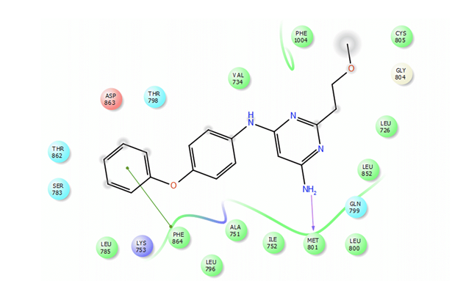
Figure s30 Docking results of COM4 that show residue and molecule contribution on the active site which obtained by Autodock Vina

Table s18 Atom energies of COM 4 obtained Molegro virtual docker
ID | Name | ETotal | EPair | EIntra
0 | C | -3.37583 | -3.47108 | 0.0952481
1 | O | -6.45661 | -5.77957 | -0.677043
2 | C | -4.94518 | -4.58431 | -0.36087
3 | C | -5.38579 | -4.96955 | -0.416239
4 | C | -2.63917 | -3.55936 | 0.920189
5 | N | -4.13962 | -5.38394 | 1.24431
6 | C | -4.91806 | -5.50237 | 0.584311
7 | C | -1.21773 | -3.45472 | 2.23699
8 | C | -1.96651 | -3.00103 | 1.03452
9 | N | -2.12575 | -2.84554 | 0.719783
10 | N | -4.54209 | -2.92542 | -1.61668
11 | C | -3.27776 | -4.85566 | 1.5779
12 | C | -5.73329 | -6.79612 | 1.06283
13 | C | -7.53192 | -7.73751 | 0.205595
14 | C | -3.76194 | -5.05786 | 1.29592
15 | C | -2.60628 | -4.54622 | 1.93994
16 | C | -4.50746 | -4.54874 | 0.0412753
19 | O | -6.40075 | -5.13861 | -1.26214
20 | C | -1.91089 | -4.38203 | 2.47113
21 | C | -4.2979 | -5.86472 | 1.56682
22 | C | -6.72724 | -7.58313 | 0.855889
23 | C | -5.2425 | -6.31797 | 1.07546
24 | C | -2.77047 | -3.6701 | 0.899631
25 | C | -2.91515 | -4.15659 | 1.24144
35 | N | -8.30426 | -7.12844 | -1.17582

Table s19 Docking results of COM4 that show residue and molecule contribution on the active site which obtained by Molegro virtual docker
Target | Residue | ID | Total | EPair
COM 4 | Ala | 751 | -8.71394 | -8.71394
COM 4 | Asp | 863 | -8.598 | -8.598
COM 4 | Cys | 805 | -4.85484 | -4.85484
COM 4 | Gln | 799 | -0.934878 | -0.934878
COM 4 | Gly | 804 | -5.01648 | -5.01648
COM 4 | Ile | 752 | -2.74404 | -2.74404
COM 4 | Leu | 726 | -3.30803 | -3.30803
COM 4 | Leu | 785 | -4.41473 | -4.41473
COM 4 | Leu | 796 | -8.43301 | -8.43301
COM 4 | Leu | 800 | -4.7358 | -4.7358
COM 4 | Leu | 852 | -11.1539 | -11.1539
COM 4 | Lys | 753 | -12.9086 | -12.9086
COM 4 | Met | 774 | -0.754163 | -0.754163
COM 4 | Met | 801 | -4.59579 | -4.59579
COM 4 | Phe | 864 | -7.54508 | -7.54508
COM 4 | Phe | 1004 | -5.59331 | -5.59331
COM 4 | Ser | 783 | -2.12274 | -2.12274
COM 4 | Thr | 798 | -7.13067 | -7.13067
COM 4 | Thr | 862 | -8.69573 | -8.69573
COM 4 | Val | 734 | -6.77797 | -6.77797

Supplementary validation of docking calculation of COM 5

Schematic and tables below representations of the binding interactions between compound 5 and HER2 TK active site.
Regarding Ala751, Ala771,Gln770, Asp 863,Leu726, Leu785, Leu796, Gly804, Leu800 , Leu852, Leu 726, Leu 785, Leu 796, Lys753, Met774, Met801, Phe864, Phe1004, Cys 805, Ile752, Ser783, Thr798, Thr862, Val 734, the biggest cavity that was found by MVD overlapped with the active sight predicted by auto dock vina. As such, these cavities were taken as the active sight in the models.
Also, the cavity with geometric position (X=12.03, Y=0.27, Z=29.73A) which was found by MVD in the predicted model, was confirmed by Autodock vina as substrate binding site.

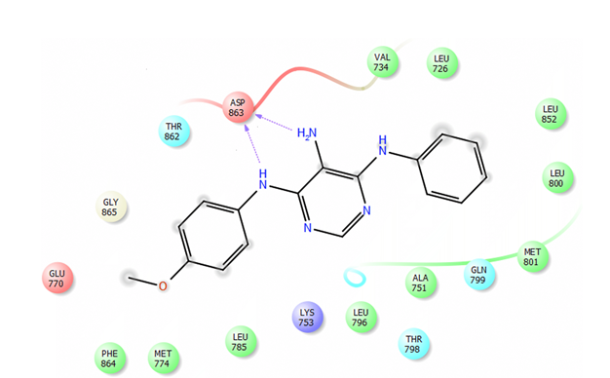
Figure s31 Docking results of COM5 that show residue and molecule contribution on the active site which obtained by Autodock Vina

Table s20 Atom energies of COM 5 obtained Molegro virtual docker
ID | Name | ETotal | EPair | EIntra
0 | C | -5.86791 | -6.64667 | 0.778757
1 | O | -6.73076 | -6.07152 | -0.659239
2 | C | -3.46618 | -4.53195 | 1.06577
3 | C | -4.2739 | -4.96976 | 0.695861
4 | C | -2.76787 | -4.70391 | 1.93604
5 | C | -3.85524 | -5.62049 | 1.76525
6 | C | -4.97958 | -5.40714 | 0.427554
7 | C | -0.673861 | -3.20829 | 2.53443
10 | N | -6.62941 | -6.87033 | 0.240921
11 | C | -3.09786 | -4.40155 | 1.30369
12 | C | -3.78821 | -4.48788 | 0.699668
13 | C | -2.74296 | -4.45508 | 1.71212
14 | N | -3.17432 | -5.0051 | 1.83078
15 | C | -7.07602 | -7.40496 | 0.328944
16 | N | -1.55065 | -4.14696 | 2.59631
18 | N | -2.56696 | -2.94998 | 0.383022
19 | C | -1.49652 | -3.09023 | 1.59372
20 | C | -1.66782 | -3.91718 | 2.24936
21 | C | -5.94779 | -6.7548 | 0.807007
22 | C | -6.13706 | -7.27376 | 1.1367
23 | C | -3.71077 | -4.81321 | 1.10244
24 | C | -2.27447 | -3.0626 | 0.788131
31 | N | -4.79292 | -6.46077 | 1.66785

Table s21 Docking results of COM5 that show residue and molecule contribution on the active site which obtained by Molegro virtual docker
Target | Residue | ID | Total | EPair
COM 5 | Ala | 751 | -8.11429 | -8.11429
COM 5 | Ala | 771 | -0.896555 | -0.896555
COM 5 | Asp | 863 | -21.7285 | -21.7285
COM 5 | Gln | 799 | -0.821274 | -0.821274
COM 5 | Glu | 770 | -2.57672 | -2.57672
COM 5 | Gly | 804 | -1.03638 | -1.03638
COM 5 | Gly | 865 | -1.0998 | -1.0998
COM 5 | Ile | 752 | -2.26943 | -2.26943
COM 5 | Leu | 726 | -1.42356 | -1.42356
COM 5 | Leu | 785 | -3.06573 | -3.06573
COM 5 | Leu | 796 | -7.72296 | -7.72296
COM 5 | Leu | 800 | -4.1139 | -4.1139
COM 5 | Leu | 852 | -8.79387 | -8.79387
COM 5 | Lys | 753 | -15.2976 | -15.2976
COM 5 | Met | 774 | -2.22886 | -2.22886
COM 5 | Met | 801 | -5.34838 | -5.34838
COM 5 | Phe | 864 | -5.86445 | -5.86445
COM 5 | Phe | 1004 | -0.975051 | -0.975051
COM 5 | Thr | 798 | -4.08336 | -4.08336
COM 5 | Thr | 862 | -8.26044 | -8.26044
COM 5 | Val | 734 | -6.07539 | -6.07539

