Geometric and electronic structures of vanadium sub-nano clusters, V_{n} (n=2-5), and their adsorption complexes with CO and O₂ ligands: A DFT-NBO study
Ali Haidar Pakiari^{*a} and Fazlolah Eshghiª
ª Department of Chemistry, College of Science, Shiraz University, Eram square, Eram Street, 7146713565, Shiraz, Iran,
*Corresponding author's e-mails: pakiariah@gmail.com.

Table 1s. NBOs, orbital hybridization in percentage, energy, and shape of NBOs in α-and β-spin parts of trimer.
NBO bonds | h_{A}—h_{B}% | Energy (a.u) | Occupancy | NBO picture
ρ=97.17% |  | α-spin part
σ_{V(1)—V(2)} | s^{5.0}d_{x2}-_{y2}^{95.0}- s^{5.0}d_{x2}-_{y2}^{95.0} | -0.1722 | 0.96 | 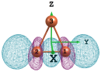
σ_{V(1)—V(3)} | s^{25.0}d_{x2}-_{y2}^{75.0}-s^{25.0}d_{x2}-_{y2}^{75.0} | -0.1689 | 0.98 | 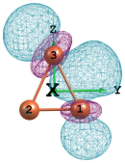
σ_{V(2)—V(3)} | s^{25.0}d_{x2}-_{y2}^{75.0}-s^{25.0}d_{x2}-_{y2}^{75.0} | -0.1689 | 0.98 | 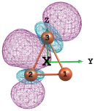
π_{V(1)—V(2)} | d_{xy}^{99.5}-d_{xy}^{99.5} | -0.1408 | 0.98 | 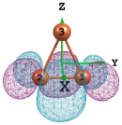
π_{V(1)—V(3)} | d_{xz}^{99.0}-d_{xz}^{99.0} | -0.1302 | 0.99 | 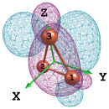
NB₍₁₎ V(3) | d _{z2}^{99.0} | -0.1099 | 0.34 | 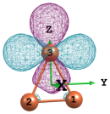
NB₍₂₎ V(3) | d_{xz}^{99.0} | -0.0979 | 0.53 | 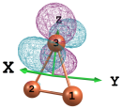
NB₍₃₎ V(3) | s^{6.0}d_{x2}-_{y2}^{94.0} | -0.0622 | 0.48 | 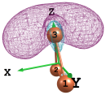
ρ=96.71% |  | β-spin part
σ_{V(1)—V(2)} | s^{7.0}d_{yz}^{93.0}-s^{7.0} d_{yz}^{93.0} | -0.1917 | 1.00 | 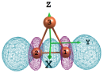
σ_{V(1)—V(3)} | s^{48.0}d _{z2}^{52.0}-s^{48.0}d _{z2}^{52.0} | -0.1862 | 0.93 | 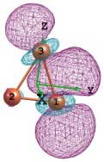
σ_{V(2)—V(3)} | s^{48.0}d _{z2}^{52.0}-s^{48.0}d _{z2}^{52.0} | -0.1862 | 0.93 | 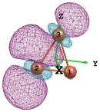
σ_{V(1)—V(2)} | s^{46.0}d _{z2}^{54.0}-s^{46.0}d _{z2}^{54.0} | -0.1710 | 0.85 | 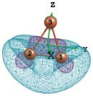
π_{V(1)—V(2)} | d_{yz}^{98.0}-d_{yz}^{98.0} | -0.1478 | 0.87 | 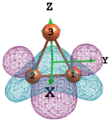
π_{V(1)—V(2)} | d_{xy}^{99.5}-d_{xy}^{99.5} | -0.1448 | 1.00 | 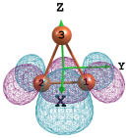
NB₍₁₎ V(1) | d_{xy}^{99.0} | -0.0749 | 0.36 | 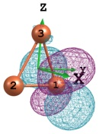
NB equals to non-bonding orbital.

Table 2s. Donor acceptor interactions of V₃ cluster
(energy is in kcal/mol.) based on second order perturbation theory.
Charge transfer Ω_{i} →Ω*_{j} | Occupancy Ω_{i} →Ω*_{j} | E₂
α-set
n_{V(3)}→n*_{V(1)} | 0.48-0.26 | 81.0
n_{V(3)}→n*_{V(2)} | 0.48-0.26 | 81.0
n_{V(3)}→σ*_{V(1)—V(3)} | 0.48-0.04 | 14.8
n_{V(3)}→σ*_{V(2)—V(3)} | 0.48-0.04 | 14.8
β-set
π_{V(1)—V(2)}→n*_{V(3)} | 0.87-0.14 | 11.8
σ_{V(1)—V(2)}→n*_{V(3)} | 0.85-0.16 | 31.3
σ_{V(1)—V(3)}→n*_{V(2)} | 0.93-0.03 | 14.7
σ_{V(2)—V(3)}→n*_{V(1)} | 0.93-0.03 | 14.7

Table 3s. NBO description of singlet distorted tetrahedron cluster with C₁ symmetry contains six σ bonds and four 3C/2e bonds for tetramer.
NBO type | Occupancy | Energy (a.u) | h_{A}—h_{B}% | NBO picture
σ_{V(1)-V(2)} | 1.89 | -0.1859 | S^{32.0}dxy^{66.0}-S^{32.0}dxz^{66.0} | 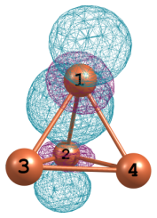
σ_{V(1)–V(3)} | 1.89 | -0.1859 | S^{32.0}dyz^{66.0}-S^{32.0}dz2^{66.} | 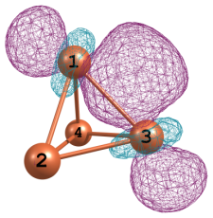
σ_{V(1)-V(4)} | 1.89 | -0.1859 | S^{32.0}dxz^{66.0}-S^{32.0}dz2⁶⁶ | 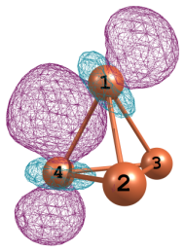
σ_{V(2)-V(3)} | 1.89 | -0.1859 | S^{32.0}dx2-y2^{66.0}-S^{32.0}dxy⁶⁶ | 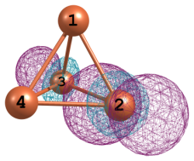
σ_{V(2)-V(4)} | 1.89 | -0.1859 | S^{32.0}dxz^{66.0}-S^{32.0}dxy⁶⁶ | 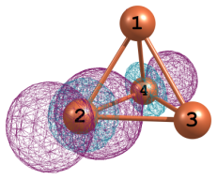
σ_{V(3)-V(4)} | 1.89 | -0.1859 | S^{32.0}dxz^{66.0}-S^{32.0}dxz⁶⁶ | 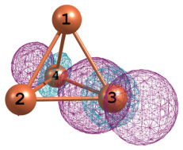
3C_{V(1)-V(2)-V(3)} | 1.94 | -0.1832 | dx²-y²-dyz-dyz | 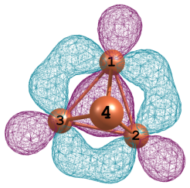
3C_{V(1)-V(2)-V(4)} | 1.94 | -0.1832 | dyz-dz²-dxz | 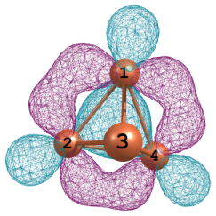
3C_{V(1)-V(4)-V(3)} | 1.94 | -0.1832 | dz²-dz²-dyz | 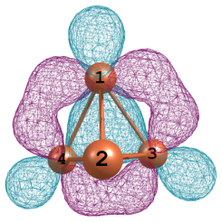
3C_{V(1)-V(2)-V(4)} | 1.94 | -0.1832 | dxy-dx²-y²-dx²-y² | 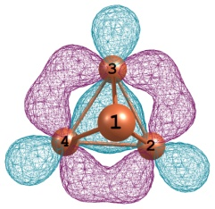

Table 4s. Bonds and lone pair in distorted trigonal bi pyramid cluster described by the NBO methodology for pentamer.
NBO type | Occupancy | Energy (a.u) | h_{A}—h_{B}% | NBO picture
α spin |  |  | %ρ=96.80
σ_{V(1)-V(3)} | 0.93 | -0.1836 | d_{z2}^{100.0}- d_{z2}^{100.0} | 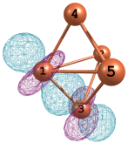
π_{V(1)–V(3)} | 0.82 | -0.1442 | d_{xz}^{98.0}- p_{x}^{10.0}d_{yz}^{90.0} | 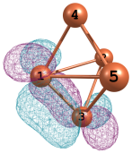
π_{V(1)–V(3)} | 0.88 | -0.2087 | s^{21.0}d_{x2}-_{y2}^{76.0}-s^{26.0}d_{x2}-_{y2}^{71.0} | 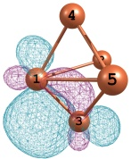
π_{V(1)–V(3)} | 0.60 | -0.1209 | s^{32.0}d_{x2}-_{y2}^{66.0}- s^{32.0}d_{xy}^{66.0} | 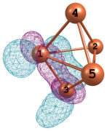
π_{V(2)–V(3)} | 0.64 | -0.1460 | d_{yz}^{99.0}- p_{z}^{18.0}d_{xz}^{82.0} | 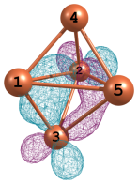
σ_{V(2)-V(4)} | 0.88 | -0.1920 | d_{z2}^{97.0}-p_{x}^{34.0}d_{z2}^{64.0} | 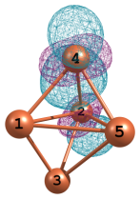
π_{V(2)-V(4)} | 0.80 | -0.1595 | s^{18.0}d_{xy}^{81.0}- s^{18.0}d_{yz}^{81.0} | 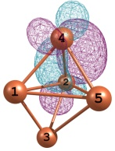
π_{V(2)-V(5)} | 0.67 | -0.1672 | s^{11.0}d_{yz}^{87.0}-s^{8.0}p_{x}^{8.0}d_{x2}-_{y2}^{84.0} | 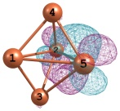
π_{V(3)-V(5)} | 0.60 | -0.1327 | p_{x}^{8.0}d_{xz}^{92.0}- p_{x}^{40.0}d_{xz}^{60.0} | 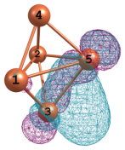
σ_{V(4)-V(5)} | 0.85 | -0.1787 | p_{z}^{34.0}d_{z2}^{64.0}- p_{z}^{16.0}d_{z2}^{82.0} | 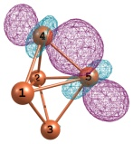
π_{V(4)-V(5)} | 0.78 | -0.1546 | s^{12.0}d_{yz}^{85.0}- s^{20.0}p_{z}^{6.0}d_{xz}^{74.0} | 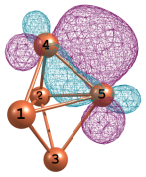
π_{V(4)-V(5)} | 0.65 | -0.1397 | s^{3.0}p_{x}^{6.0}d_{yz}^{91.0}- p_{z}^{27.0}d_{z2}^{73.0} | 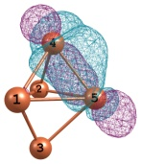
NB₍₁₎ V(1) | 0.57 | -0.1119 | s^{16.0}d _{z2}^{84.0} | 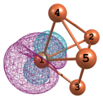
β spin |  |  | %ρ=95.30
π_{V(1)-V(2)} | 0.45 | -0.1244 | p_{x}^{3.0}d_{xz}^{91.0}- p_{x}^{27.0}d _{z2}^{73.0} | 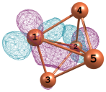
σ_{V(1)-V(3)} | 0.88 | -0.1475 | p_{x}^{13.0}d _{z2}^{87.0}- d _{z2}^{98.0} | 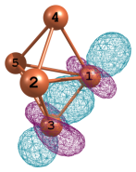
π_{V(1)-V(3)} | 0.76 | -0.1594 | p_{x}^{9.0}d_{xz}^{91.0}- p_{z}^{3.0}d_{yz}^{97.0} | 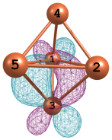
π_{V(1)-V(3)} | 0.73 | -0.1722 | s^{4.0}p_{x}^{6.0}d_{x2}-_{y2}^{90.0}-p_{z}^{3.0}d_{x2}-_{y2}^{97.0} | 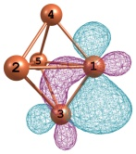
π_{V(1)-V(4)} | 0.74 | -0.1482 | p_{x}^{4.0}d_{xz}^{96.0}- d_{xz}^{97.0} | 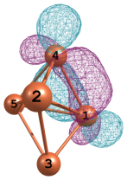
π_{V(2)-V(3)} | 0.69 | -0.1438 | p_{x}^{4.0} d_{xy}^{96.0}- p_{x}^{3.0} d_{xy}^{97.0} | 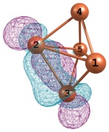
σ_{V(2)-V(4)} | 0.85 | -0.1827 | s^{32.0}d _{z2}^{67.0}-s^{13.0}d _{z2}^{86.0} | 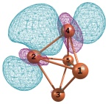
π_{V(2)-V(4)} | 0.72 | -0.1524 | d_{xz}^{98.0}- d_{x2}-_{y2}^{97.0} | 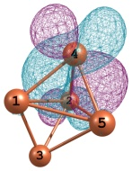
σ_{V(2)-V(4)} | 0.60 | -0.1733 | s^{11.0}d _{z2}^{88.0}-s^{9.0}d _{z2}^{90.0} | 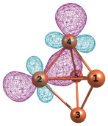
σ_{V(4)-V(5)} | 0.88 | -0.1818 | s^{9.0}d _{z2}^{90.0}-s^{14.0}d _{z2}^{83.0} | 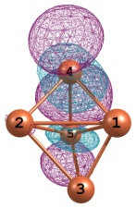
NB₍₁₎ V(2) | 0.72 | -0.1294 | d _{z2} | 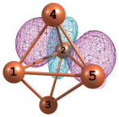
NB₍₁₎ V(5) | 0.71 | -0.1256 | d_{yz} | 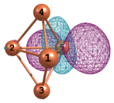

Table 5s. Donor acceptor interactions of pentamer (energy is in kcal/mol.).
Charge transfer Ωi →Ω*j | Occupancy Ωi →Ω*j | E₂
α-set
π_{V(1)—V(3)}→σ*_{V(2)—V(3)} | 0.60-0.11 | 8.2
σ_{V(2)—V(4)}→n*_{V(1)} | 0.88-0.22 | 11.6
σ_{V(2)—V(4)}→n*_{V(5)} | 0.88-0.23 | 12.1
π_{V(2)—V(5)}→n*_{V(3)} | 0.67-0.29 | 22.6
π_{V(2)—V(5)}→n*_{V(4)} | 0.67-0.29 | 29.3
σ_{V(4)—V(5)}→n*_{V(1)} | 0.85-0.22 | 14.6
σ_{V(4)—V(5)}→n*_{V(2)} | 0.85-0.24 | 14.1
n_{V(1)}→n*_{V(2)} | 0.57-0.24 | 8.2
n_{V(1)}→n*_{V(3)} | 0.57-0.29 | 44.9
β-set
π_{V(1)—V(2)}→n*_{V(3)} | 0.45-0.22 | 77.5
π_{V(1)—V(2)}→n*_{V(5)} | 0.45-0.37 | 79.8
π_{V(1)—V(3)}→n*_{V(5)} | 0.73-0.37 | 23.7
π_{V(1)—V(4)}→n*_{V(5)} | 0.74-0.37 | 24.2
π_{V(1)—V(3)}→n*_{V(5)} | 0.73-0.37 | 21.3
σ_{V(2)—V(4)}→n*_{V(1)} | 0.69-0.24 | 36.7
σ_{V(2)—V(3)}→n*_{V(5)} | 0.60-0.37 | 52.1
n_{V(5)}→n*_{V(3)} | 0.72-0.22 | 13.4

Table 6s. Significant Donor acceptor interactions of V_{n}CO (n=2-5), energy (ΔE) in β-spin part.
Complex | elongation of C―O bond (Å) | donation | E₂ (kcal/mol) | back-donation | E₂ (kcal/mol)
V₂CO | 0.085 | σ_{V(1)-C(4)} → n*_{V(2)} | 91.1 | n_{O(3)}→ σ*_{V(2)-C(4)} | 41.4
V₃CO | 0.119 | σ_{V(1)-C(5)} → n*_{V(2)} | 14.3 | σ_{V(1)-V(2)} → σ*_{V(1)-C(5)} | 14.9
 |  | σ_{V(1)-C(5)} → n*_{V(3)} | 20.4 | n_{O(4)}→π*_{V(1)-C(5)} | 41.1
V₄CO |  | σ_{V(2)-C(5)} → n*_{V(3)} | 131.5 | - | -
V₅CO |  | Not considerable | - | Not considerable | -

Table 7s. Number of bonds, occupancies, and distance of bond, d, (Å),
of the V_{n}CO (n=2-5) complexes at α and β-spin sets.
structure | V₂CO | V₍₁₎-C₍₄₎ | V₍₂₎-C₍₄₎
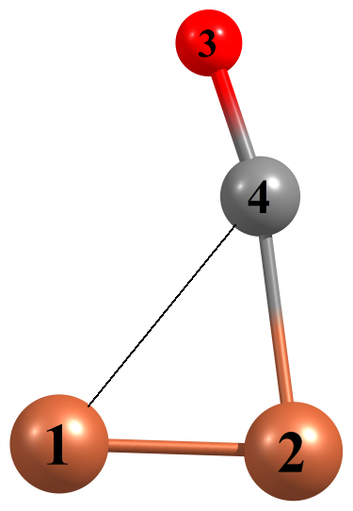 | OCC | σ_{α}:0.81, n_{C}: 0.81 | σ_{β}: 0.82  σ_{β}:0.81
 | d (Å) | 2.397 | 1.929
V₃CO |  | V₍₁₎-C₍₅₎ | V₍₃₎-C₍₅₎
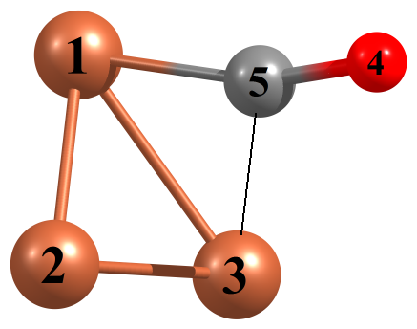 | OCC | σ_{α}: 0.94  σ_{β}:0.91, π_{β}:0.80 | σ_{α}: 0.87
 | d (Å) | 1.902 | 2.215
V₄CO |  | V₍₁₎-C₍₅₎ | V₍₃₎-C₍₅₎
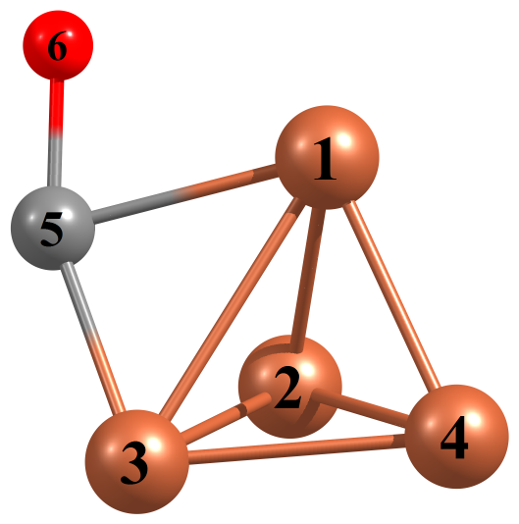 | OCC | σ_{α}: 1.55,  σ_{α}: 1.47  n_{C}: 0.86 | π_{α}: 1.47
 | d (Å) | 1.877 | 2.026
V₅CO |  | V₍₁₎-C₍₆₎ | V₍₂₎-C₍₆₎
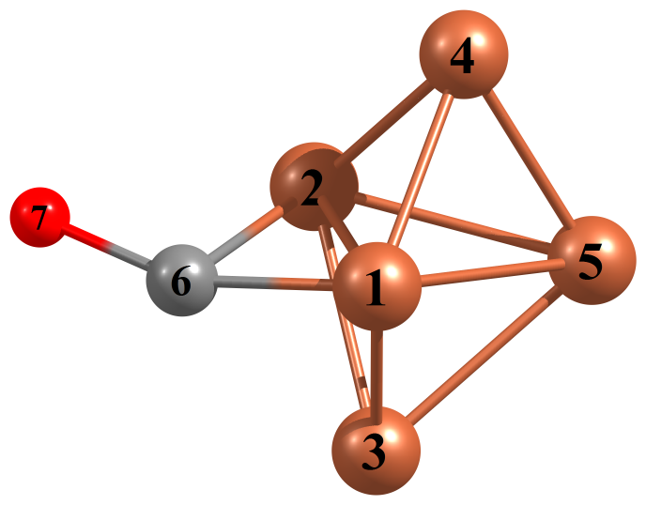 | OCC | π_{α}:0.63, π_{α}:0.66  π_{β}:0.75 | σ_{α}:0.69
 | d (Å) | 1.925 | 2.009

Table 8s. Number of bonds, occupancies, and distance of bond, d, (Å), of the V_{n}O₂ (n=2-5) complexes at α and β-spin sets.
structure | V₂O₂ | V₍₁₎-O₍₃₎ | V₍₁₎-O₍₄₎ | V₍₂₎-O₍₃₎ | -
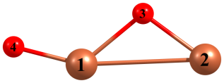 | OCC | σ_{α}:0.95, π_{α}: 0.93  σ_{β}:0.95, π_{β}: 0.93 | π_{α}: 0.98, σ_{α}: 1.00, π_{α}: 0.97  π_{β}: 0.98, σ_{β}: 1.00, π_{β}: 0.97 | σ_{α}: 0.96  σ_{β}: 0.96 | -
 | d (Å) | 1.856 | 1.630 | 1.799 | -
V₃O₂ |  | V₍₁₎-O₍₄₎ | V₍₁₎-O₍₅₎ | V₍₂₎-O₍₅₎ | V₍₃₎-O₍₄₎
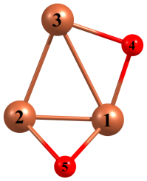 | OCC | σ_{α}: 0.92, π_{α}: 0.94  σ_{β}:0.90 | σ_{α}: 0.95, π_{α}: 0.90  σ_{β}:0.87, σ_{β}:0.84 | σ_{α}: 0.96 | σ_{α}: 0.96
 | d (Å) | 1.819 | 1.867 | 1.843 | 1.811
V₄O₂ |  | V₍₁₎-O₍₅₎ | V₍₂₎-O₍₅₎ | V₍₂₎-O₍₆₎ | V₍₃₎-O₍₆₎
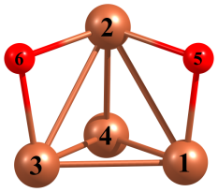 | OCC | σ_{α}: 0.95, π_{α}: 0.91  σ_{β}:0.95, π_{β}: 0.91 | σ_{α}: 0.96  σ_{β}:0.94 | σ_{α}: 0.96  σ_{β}: 0.95, π_{β}: 0.89 | σ_{α}:0.95, π_{α}: 0.91  σ_{β}: 0.94
 | d (Å) | 1.810 | 1.834 | 1.833 | 1.819
V₅O₂ |  | V₍₁₎-O₍₇₎ | V₍₁₎-O₍₆₎ | V₍₄₎-O₍₇₎ | V₍₃₎-O₍₆₎
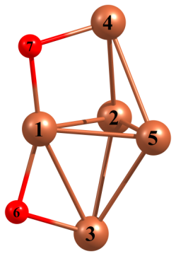 | OCC | σ_{α}:0.95  σ_{β}:0.95 | σ_{α}:0.95  σ_{β}:0.95 | σ_{α}:0.91  σ_{β}:0.91 | σ_{α}:0.91  σ_{β}:0.91
 | d (Å) | 1.824 | 1.824 | 1.835 | 1.835

