Conductometric and refractometric study of 1-Propyl-3-methylimidazolium bromide ionic liquid in water + ethylene carbonate mixtures at T = (298.2, 308.2 and 318.2) K
Bahram Ghalami-Choobar*, Tayyebe Nosrati Fallahkar
Department of Chemistry, Faculty of Science, University of Guilan, P.O. Box: 19141, Rasht, Iran
* Corresponding author. Tel.:+981313233262; Fax: +981313233262
E-mail address:B-Ghalami@guilan.ac.ir (B.Ghalami-Choobar)

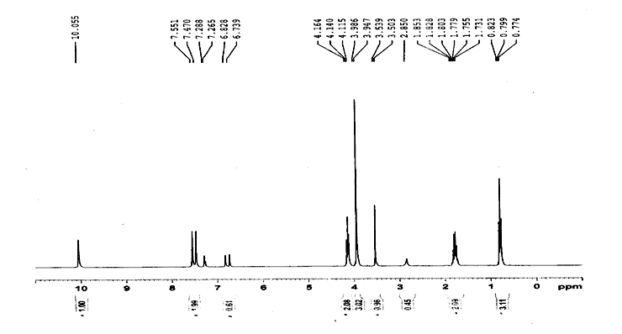

Figure S1. ¹H NMR spectrum of 1-ethyl-3-methylimidazolium bromide

Figure S1.¹H NMR spectrum of 1-propyl-3-methylimidazolium bromide

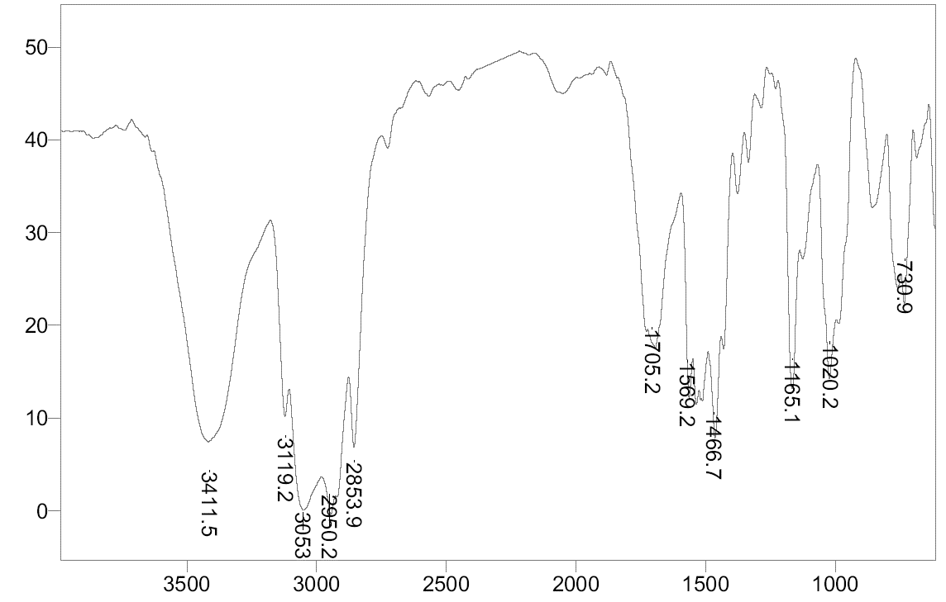
Wavenumber (cm⁻¹)
Transmittance (%)

Figure S2. FT-IR spectrum of 1-propyl-3-methylimidazolium bromide

Figure S3. Molar conductivity of [PrMIm]Br against molal concentration (m_{IL}) of ionic liquid in mass fraction 10% (w_{EC}/w_{mixture}).

Figure S4. Molar conductivity of [PrMIm]Br against molal concentration (m_{IL}) of ionic liquid in mass fraction 20% (w_{EC}/w_{mixture}).

Table S1. The values of coefficients in Eq (16) A₀, A₁ and A₂ at different solvent compositions
w% | A₀ (kJ.mol⁻¹) | A₁ (kJ.mol⁻¹.K⁻¹) | A₂ (kJ.mol⁻¹.K⁻²)
10 | -1.7426 | 0.1756 | 0.0013
20 | -1.1769 | 0.2600 | 0.0046
30 | -0.6335 | 0.2388 | 0.0029

Table S2. Coefficients of Redlich-Kister equation (A_{i}) and standard deviations (σ) for binary mixtures at 298.2, 308.2 and 318.2 K
 | A₀ | A₁ | A₂ | A₃ | σ
T/K = 298.2
Water + EC | 0.1072 | 0.0654 | 0.0635 | 0.0469 | 0.0005
Water + [PrMIm]Br | 0.3145 | 0.2103 | 0.2166 | 0.1500 | 0.0029
EC + [PrMIm]Br | 0.0966 | 0.0346 | 0.0296 | 0.0187 | 0.0005
T/K = 308.2
Water + EC | 0.1039 | 0.0504 | 0.0592 | 0.0669 | 0.0008
Water + [PrMIm]Br | 0.2982 | 0.2108 | 0.2148 | 0.1593 | 0.0023
EC + [PrMIm]Br | 0.0992 | 0.0350 | 0.0217 | 0.0248 | 0.0003
T/K=318.2
Water + EC | 0.1022 | 0.0503 | 0.0632 | 0.0699 | 0.0010
Water + [PrMIm]Br | 0.2923 | 0.2185 | 0.2065 | 0.1611 | 0.0023
EC + [PrMIm]Br | 0.0100 | 0.0413 | 0.0117 | 0.0250 | 0.0007

Table S3. Adjustable coefficients of Cibulka equation (B_{i}) and standard deviations (σ) for water + EC + ionic liquid mixtures at T = 298.2, 308.2 and 318.2 K
T/K | B₀ | B₁ | B₂ | σ
298.2 | 0.1270 | -0.0305 | -0.0117 | 0.0010
308.2 | 0.2461 | -0.1206 | -0.2294 | 0.0010
318.2 | 0.2645 | -0.1295 | -0.3330 | 0.0009

Table S4. Average percentage deviation (APD) in Lorentz–Lorenz (L–L), Gladstone–Dale (G–D), Eykman (EK), Newton (N), Heller (H) and Edwards relations in binary and ternary investigated mixtures of this work
T/K | L-L | G-D | EK | N | H | Ed
Water + EC
298.2 | 0.1449 | 0.1109 | 0.1938 | 0.0799 | 0.1614 | 0.1828
308.2 | 0.0996 | 0.0752 | 0.1454 | 0.0584 | 0.1163 | 0.1348
318.2 | 0.1127 | 0.0831 | 0.1594 | 0.0687 | 0.1289 | 0.1490
<APD> | 0.12 | 0.09 | 0.17 | 0.07 | 0.14 | 0.16
Water + [PrMIm]Br
298.2 | 0.4501 | 0.5707 | 0.2989 | 0.6810 | 0.4341 | 0.3411
308.2 | 0.5788 | 0.7040 | 0.4140 | 0.8172 | 0.4710 | 0.4602
318.2 | 0.7167 | 0.8440 | 0.5485 | 0.9593 | 0.5401 | 0.5954
<APD> | 0.58 | 0.71 | 0.42 | 0.82 | 0.48 | 0.47
EC + [PrMIm]Br
298.2 | 0.0469 | 0.0475 | 0.1202 | 0.0840 | 0.0645 | 0.0974
308.2 | 0.0643 | 0.0250 | 0.1383 | 0.0668 | 0.0797 | 0.1162
318.2 | 0.0508 | 0.0875 | 0.0835 | 0.1445 | 0.0337 | 0.0651
<APD> | 0.05 | 0.05 | 0.11 | 0.10 | 0.06 | 0.10
Water + EC + [PrMIm]Br
298.2 | 0.0905 | 0.1140 | 0.2091 | 0.2353 | 0.1614 | 0.1601
308.2 | 0.0831 | 0.1627 | 0.1559 | 0.2945 | 0.1393 | 0.1205
318.2 | 0.1187 | 0.2646 | 0.0863 | 0.4009 | 0.1116 | 0.0696
<APD> | 0.10 | 0.18 | 0.15 | 0.31 | 0.14 | 0.12

