Optoelectronic and photovoltaic properties in a P3HT/PCBM complex:
A TD-DFT study

Ahlam El Ghazaliª, Abdelkhalk Aboulouard^{b}, Said Zouitinaª, SalimaAtlas^{c}, Mohammed El idrissi^{d*} and Abdessamad Tounsiª
ªRTACM, Polydisciplinary Faculty, Sultan Moulay Slimane University, Beni-Mellal, Morocco.
^{b}Department of Physics, Sultan Moulay Slimane University, Beni-Mellal, Morocco.
^{c}Polydisciplinary Faculty Sultan Moulay Slimane University, Beni-Mellal, Morocco
^{d}TCPAM, Polydisciplinary Faculty, Sultan Moulay Slimane University, Beni-Mellal, Morocco.
* Corresponding author: m.elidrissi2018@gmail.com
Table of contents | Pages
Fig. 1S. Electrical dipole moment (D) of all compounds at TD-DFT B3LYP/6-31 G(d,p). | S2
Fig. 2S. Plots (a) polarizability (α): (b): hyperpolarizability (β) of all compounds at the TD-DFT level B3LYP/6-31 G(d,p). | S2
Table 1S. Mulliken charges obtained by B3LYP/6-31G (d,P) | S3
Table 2S. Accumulation of the electron population of atoms in the core, valence and rydberg orbitals obtained by B3LYP/6-31G (d,P). | S5
Table 3S. NBO charges obtained by B3LYP/6-31G (d,P) | S6
Fig. 3S. NBO and Mulliken charge curves obtained by B3LYP/6-31G (d,P) | S9-S10

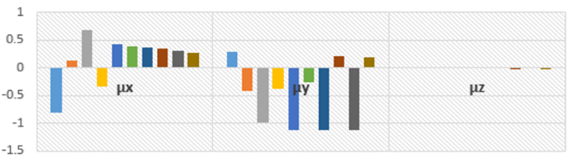
M(n=1)
M(n=6)
M(n=2)
M(n=7)
M(n=3)
M(n=4)
M(n=5)
M(n=8)
M(n=9)
M(n=10)
Fig. 1S. Electrical dipole moment (DM) of all compounds at TD-DFT B3LYP/6-31 G(d,p).

Fig. 2S. Plots (a) polarizability (α): (b): hyperpolarizability (β) of all compounds at the TD-DFT level B3LYP/6-31 G(d,p).

Table 1S. Mulliken charges obtained by B3LYP/6-31G (d,P).
M (n1)
C1 = 0.006 |  |  | C2 =0.010 |  |  |  | C3 =0.004 |  |  | C4= 0.002 |  |  |  |  |  | S1= 0.487 |  |  |  |  |  |  | C5= 0.024 |  |  |  |  |  | C6=0.041 |  |  |  |  |  | C7=0.102
C8=-0.391 |  |  | C9=0.059 |  |  |  | C10=-0.333 |  |  | ------- |  |  |  |  |  | ------- |  |  |  |  |  |  | ------- |  |  |  |  |  | ------- |  |  |  |  |  | -------
M (n2)
C1 = -0.012 |  | C2 =0.007 |  |  |  | C3 =0.009 |  | C4=0.004 |  |  |  |  |  | S1= 0.549 |  |  |  |  |  |  | C5= 0.008 |  |  |  |  |  | C6=-0.006 |  |  |  |  |  | C7=0.122
C8= -0.397 |  | C9=0.084 |  |  |  | C10=-0.384 |  | C11=-0.408 |  |  |  |  |  | C12=0.140 |  |  |  |  |  |  | S2= 0.521 |  |  |  |  |  | C13=0.016 |  |  |  |  |  | C14=0.003
C15=0.006 |  | C16=0.009 |  |  |  | C17 =0.007 |  | C18=-0.013 |  |  |  |  |  | C19=0.077 |  |  |  |  |  |  | C20=-0.349 |  |  |  |  |  | ------- |  |  |  |  |  | -------
M (n3)
C1 =-0.012 |  |  | C2 =0.007 |  |  |  | C3 =0.009 |  | C4= 0.004 |  |  |  |  |  | S1= 0.550 |  |  |  |  |  |  | C5=0.008 |  |  |  |  |  | C6=-0.007 |  |  |  |  |  | S2= 0.519
C7=0.123 |  |  | C8=-0.490 |  |  |  | C9=0.082 |  | C10=-0.398 |  |  |  |  |  | S3=0.523 |  |  |  |  |  |  | C11=-0.413 |  |  |  |  |  | C12=0.113 |  |  |  |  |  | C13=0.014
C14= 0.007 |  |  | C15=0.005 |  |  |  | C16=0.010 |  | C17 = 0.007 |  |  |  |  |  | C18=-0.013 |  |  |  |  |  |  | C19=0.061 |  |  |  |  |  | C20=-0.369 |  |  |  |  |  | C21=0.421
C22=0.143 |  |  | C23=0.016 |  |  |  | C24=0.004 |  | C25=0.006 |  |  |  |  |  | C26=0.009 |  |  |  |  |  |  | C27=0.007 |  |  |  |  |  | C28=-0.012 |  |  |  |  |  | C29=0.077
C30=-0.348 |  |  | ------- |  |  |  | ------- |  | -------
M (n4)
C1 = -0.012 |  | C2 =0.007 |  |  |  | C3 =0.009 |  | C4= 0.004 |  |  |  |  | S1= 0.550 |  |  |  |  |  |  | C5= -0.465 |  |  |  |  |  | C6=-0.465 |  |  |  |  |  | S2= 0.519
C7=0.123 |  | C8=-0.396 |  |  |  | C9=0.082 |  | C10= -0.253 |  |  |  |  | S3=0.600 |  |  |  |  |  |  | C11=-0.254 |  |  |  |  |  | C12=-0.041 |  |  |  |  |  | C13=-0.482
C14= -0.459 |  | S4=0.524 |  |  |  | C15=0.006 |  | C16=-0.457 |  |  |  |  | C17 = 0.007 |  |  |  |  |  |  | C18=-0.013 |  |  |  |  |  | C19=0.059 |  |  |  |  |  | C20=-0.382
C21=-0.426 |  | C22=0.115 |  |  |  | C23=0.013 |  | C24=0.007 |  |  |  |  | C25=0.005 |  |  |  |  |  |  | C26=0.011 |  |  |  |  |  | C27=0.006 |  |  |  |  |  | C28= -0.012
C29=0.060 |  | C30=-0.367 |  |  |  | C31=-0.421 |  | C32=0.143 |  |  |  |  | C33=0.016 |  |  |  |  |  |  | C34=0.004 |  |  |  |  |  | C35=0.006 |  |  |  |  |  | C36=0.009
C37=0.007 |  | C38=-0.012 |  |  |  | C39=0.077 |  | C40=-0.347 |  |  |  |  | ------- |  |  |  |  |  |  | ------- |  |  |  |  |  | ------- |  |  |  |  |  | -------
M (n5)
C1 =-0.012 |  | C2 =0.007 |  |  |  | C3 =0.009 |  | C4= 0.004 |  |  |  |  | S1= 0.550 |  |  |  |  |  |  | C5= 0.008 |  |  |  |  |  | C6=-0.007 |  |  |  |  |  | S2= 0.598
C7=0.123 |  | C8=-0.490 |  |  |  | C9=0.082 |  | C10=-0.253 |  |  |  |  | S3= 0.601 |  |  |  |  |  |  | C11=-0.411 |  |  |  |  |  | C12=0.112 |  |  |  |  |  | C13=0.014
C14= 0.006 |  | S4= 0.600 |  |  |  | C15=0.006 |  | C16=0.009 |  |  |  |  | C17 = 0.007 |  |  |  |  |  |  | C18=-0.013 |  |  |  |  |  | C19= 0.060 |  |  |  |  |  | S5=0.524
C20= -0.383 |  | C21=-0.425 |  |  |  | C22= 0.115 |  | C23=0.013 |  |  |  |  | C24=0.007 |  |  |  |  |  |  | C25= 0.005 |  |  |  |  |  | C26= 0.010 |  |  |  |  |  | C27= 0.007
C28= -0.012 |  | C29= 0.058 |  |  |  | C30= -0.381 |  | C31=-0.427 |  |  |  |  | C32= 0.115 |  |  |  |  |  |  | C33= 0.013 |  |  |  |  |  | C34= 0.008 |  |  |  |  |  | C35=0.005
C36=0.011 |  | C37=0.007 |  |  |  | C38=-0.012 |  | C39=0.060 |  |  |  |  | C40=-0.367 |  |  |  |  |  |  | C41=-0.421 |  |  |  |  |  | C42=0.143 |  |  |  |  |  | C43=0.016
C44=0.004 |  | C45=0.006 |  |  |  | C46= 0.009 |  | C47=0.007 |  |  |  |  | C48=-0.012 |  |  |  |  |  |  | C49=0.077 |  |  |  |  |  | C50=-0.347 |  |  |  |  |  | -------
M (n=6)
C1 = -0.012 | C2 =0.007 |  |  | C3 =0.009 |  |  |  | C4= 0.004 |  |  | S1= 0.549 |  |  |  |  |  | C5= 0.008 |  |  |  |  |  |  | C6= -0.006 |  |  |  |  |  | S2= 0.598
C7=0.123 | C8=-0.396 |  |  | C9= 0.082 |  |  |  | C10=-0.398 |  |  | S3=0.600 |  |  |  |  |  | C11=-0.411 |  |  |  |  |  |  | C12=0.112 |  |  |  |  |  | C13=0.014
C14=0.006 | S4=0.601 |  |  | C15=0.006 |  |  |  | C16=0.009 |  |  | C17=0.007 |  |  |  |  |  | C18=-0.013 |  |  |  |  |  |  | S5=0.600 |  |  |  |  |  | C19=0.059
C20=-0.383 | C21=-0.425 |  |  | C22=0.114 |  |  |  | C23=0.013 |  |  | C24=0.007 |  |  |  |  |  | C25=0.005 |  |  |  |  |  |  | C26=0.010 |  |  |  |  |  | C27=0.007
C28=-0.012 | C29=0.058 |  |  | C30=-0.382 |  |  |  | C31=-0.425 |  |  | C32=0.115 |  |  |  |  |  | C33=0.013 |  |  |  |  |  |  | C34=0.007 |  |  |  |  |  | C35=0.005
C36=0.010 | C37=0.007 |  |  | C38=-0.012 |  |  |  | C39=0.058 |  |  | C40=-0.381 |  |  |  |  |  | C41=-0.427 |  |  |  |  |  |  | C42=0.115 |  |  |  |  |  | C43=0.013
C44=0.008 | C45=0.005 |  |  | C46=0.011 |  |  |  | C47=0.007 |  |  | C48=-0.012 |  |  |  |  |  | C49=0.060 |  |  |  |  |  |  | C50=-0.367 |  |  |  |  |  | C51=-0.421
C52=0.143 | S6=0.524 |  |  | C53=0.016 |  |  |  | C54=0.004 |  |  | C55=0.006 |  |  |  |  |  | C56=0.009 |  |  |  |  |  |  | C57= 0.007 |  |  |  |  |  | C58=-0.012
C59=0.077 | C60=-0.347 |  |  | ------- |  |  |  | ------- |  |  | ------- |  |  |  |  |  | ------- |  |  |  |  |  |  | ------- |  |  |  |  |  | -------
M (n=7)
C1 = -0.012 |  | C2 =0.007 |  |  | C3 =0.009 |  |  | C4= 0.004 |  |  |  | S1=0.550 |  |  |  |  |  |  | C5=0.008 |  |  |  |  |  | C6=-0.007 |  |  |  |  |  | S2=0.598
C7=0.123 |  | C8=-0.396 |  |  | C9=0.082 |  |  | C10= -0.398 |  |  |  | S3=0.600 |  |  |  |  |  |  | C11=-0.411 |  |  |  |  |  | C12=0.112 |  |  |  |  |  | C13=0.014
C14=0.006 |  | S4=0.600 |  |  | C15=0.006 |  |  | C16=0.009 |  |  |  | C17=0.007 |  |  |  |  |  |  | C18= -0.013 |  |  |  |  |  | S5=0.601 |  |  |  |  |  | C19=0.059
C20=-0.383 |  | C21=-0.425 |  |  | C22=0.114 |  |  | C23=0.013 |  |  |  | C24=0.007 |  |  |  |  |  |  | C25=0.005 |  |  |  |  |  | C26= 0.010 |  |  |  |  |  | C27=0.007
C28=-0.012 |  | C29=0.058 |  |  | C30 =-0.382 |  |  | C31 =-0.425 |  |  |  | C32 =0.115 |  |  |  |  |  |  | C33 =0.013 |  |  |  |  |  | C34=0.007 |  |  |  |  |  | C35 =0.005
C36=0.010 |  | C37=0.007 |  |  | C38=-0.012 |  |  | C39=0.059 |  |  |  | C40=-0.382 |  |  |  |  |  |  | C41=-0.425 |  |  |  |  |  | C42=0.115 |  |  |  |  |  | C43=0.013
C44=0.007 |  | C45=0.005 |  |  | C46=0.010 |  |  | C47=0.007 |  |  |  | C48=-0.012 |  |  |  |  |  |  | C49=0.058 |  |  |  |  |  | C50=0.058 |  |  |  |  |  | C51=-0.427
C52=0.115 |  | S6=0.600 |  |  | C53=0.013 |  |  | C54=0.008 |  |  |  | C55=0.005 |  |  |  |  |  |  | C56=0.011 |  |  |  |  |  | S7=0.524 |  |  |  |  |  | C57=0.007
C58=-0.012 |  | C59=0.060 |  |  | C60=-0.367 |  |  | C61=-0.421 |  |  |  | C62=0.143 |  |  |  |  |  |  | C63=0.016 |  |  |  |  |  | C64=0.004 |  |  |  |  |  | C65=0.006
C66=0.009 |  | C67=0.007 |  |  | C68=-0.012 |  |  | C69=0.077 |  |  |  | C70=-0.347 |  |  |  |  |  |  | ------- |  |  |  |  |  | ------- |  |  |  |  |  | -------
M (n=8)
C1 = -0.012 |  | C2 =0.007 |  |  | C3 =0.009 |  |  | C4= 0.004 |  |  |  | S1=0.550 |  |  |  |  |  |  | C5=0.008 |  |  |  |  |  | C6=-0.007 |  |  |  |  |  | S2=0.598
C7=0.123 |  | C8=-0.396 |  |  | C9=0.082 |  |  | C10= -0.398 |  |  |  | S3=0.600 |  |  |  |  |  |  | C11=-0.411 |  |  |  |  |  | C12=0.112 |  |  |  |  |  | C13=0.014
C14=0.006 |  | S4=0.600 |  |  | C15=0.006 |  |  | C16=0.009 |  |  |  | C17=0.007 |  |  |  |  |  |  | C18= -0.013 |  |  |  |  |  | S5=0.600 |  |  |  |  |  | C19=0.060
C20=-0.383 |  | C21=-0.425 |  |  | C22=0.115 |  |  | S6=0.601 |  |  |  | C23=0.013 |  |  |  |  |  |  | C24=0.007 |  |  |  |  |  | C25= 0.005 |  |  |  |  |  | C26=0.010
S7=0.600 |  | C27=0.007 |  |  | C28=-0.012 |  |  | C29=0.058 |  |  |  | C30 =-0.382 |  |  |  |  |  |  | S8=0.524 |  |  |  |  |  | C31 =-0.425 |  |  |  |  |  | C32 =0.115
C33=0.013 |  | C34=0.007 |  |  | C35 =0.005 |  |  | C36=0.010 |  |  |  | C37=0.007 |  |  |  |  |  |  | C38=-0.012 |  |  |  |  |  | C39=0.058 |  |  |  |  |  | C40= -0.382
C41=-0.425 |  | C42=0.115 |  |  | C43=0.013 |  |  | C44=0.007 |  |  |  | C45=0.005 |  |  |  |  |  |  | C46=0.010 |  |  |  |  |  | C47=0.007 |  |  |  |  |  | C48=-0.012
C49=0.058 |  | C50=-0.381 |  |  | C51=-0.425 |  |  | C52=0.115 |  |  |  | C53=0.013 |  |  |  |  |  |  | C54=0.007 |  |  |  |  |  | C55=0.005 |  |  |  |  |  | C56=0.010
C57=0.007 |  | C58=-0.012 |  |  | C59=0.058 |  |  | C60=-0.381 |  |  |  | C61=-0.427 |  |  |  |  |  |  | C62=0.115 |  |  |  |  |  | C63=0.013 |  |  |  |  |  | C64=0.008
C65=0.005 |  | C66=0.011 |  |  | C67=0.007 |  |  | C68=-0.012 |  |  |  | C69=0.060 |  |  |  |  |  |  | C70=-0.367 |  |  |  |  |  | C71=-0.421 |  |  |  |  |  | C72=0.143
C73=0.016 |  | C74=0.004 |  |  | C75=0.006 |  |  | C76=0.009 |  |  |  | C77=0.007 |  |  |  |  |  |  | C78=-0.012 |  |  |  |  |  | C79= 0.077 |  |  |  |  |  | C80=-0.347
M (n=9)
C1 =-0.012 | C2 =0.007 |  |  | C3 =0.009 |  |  |  | C4=0.004 |  |  |  | S1=0.550 |  |  |  |  |  | C5=0.008 |  |  |  |  |  |  | C6=-0.0071 |  |  |  |  |  | S2=0.598
C7=0.123 | C8=-0.396 |  |  | C9=0.082 |  |  |  | C10=-0.398 |  |  |  | S3=0.600 |  |  |  |  |  | C11=-0.411 |  |  |  |  |  |  | C12=0.112 |  |  |  |  |  | C13=0.014
C14=0.006 | S4=0.600 |  |  | C15=0.006 |  |  |  | C16=0.009 |  |  |  | C17=0.007 |  |  |  |  |  | C18=-0.013 |  |  |  |  |  |  | S5=0.601 |  |  |  |  |  | C19=0.059
C20=-0.383 | C21=-0.425 |  |  | C22=0.114 |  |  |  | C23=0.013 |  |  |  | C24=0.007 |  |  |  |  |  | C25=0.005 |  |  |  |  |  |  | C26=0.010 |  |  |  |  |  | C27=0.007
C28=0.007 | C29=0.058 |  |  | C30=-0.382 |  |  |  | C31=-0.425 |  |  |  | C32=0.115 |  |  |  |  |  | C33=0.013 |  |  |  |  |  |  | C34=0.007 |  |  |  |  |  | C35=0.005
C36=0.010 | C37=0.007 |  |  | C38=-0.012 |  |  |  | C39=0.058 |  |  |  | C40=-0.382 |  |  |  |  |  | C41=-0.425 |  |  |  |  |  |  | C42=0.115 |  |  |  |  |  | C43=0.013
C44=0.007 | C45=0.005 |  |  | C46=0.010 |  |  |  | C47=0.007 |  |  |  | C48=-0.012 |  |  |  |  |  | C49=0.058 |  |  |  |  |  |  | C50=-0.382 |  |  |  |  |  | C51=-0.425
C52=0.115 | S6=0.115 |  |  | C53=0.013 |  |  |  | C54=0.007 |  |  |  | C55=0.005 |  |  |  |  |  |  | C56=0.010 |  |  |  |  |  | S7=0.010 |  |  |  |  |  | C57=0.007
C58=-0.012 | C59=0.059 |  |  | C60=-0.381 |  |  |  | C61=-0.425 |  |  |  | C62=0.115 |  |  |  |  |  |  | C63=0.013 |  |  |  |  |  | C64=0.007 |  |  |  |  |  | C65=0.005
C66=0.010 | C67=0.007 |  |  | C68=-0.012 |  |  |  | C69=0.058 |  |  |  | C70=-0.381 |  |  |  |  |  |  | C71=-0.427 |  |  |  |  |  | C72=0.115 |  |  |  |  |  | S8=0.601
C73=0.013 | C74=0.008 |  |  | C75=0.005 |  |  |  | C76=0.011 |  |  |  | S9=0.524 |  |  |  |  |  |  | C77=0.007 |  |  |  |  |  | C78= -0.012 |  |  |  |  |  | C79=0.061
C80=-0.367 | C81=-0.421 |  |  | C82=0.143 |  |  |  | C83=0.016 |  |  |  | C84=0.004 |  |  |  |  |  |  | C85=0.006 |  |  |  |  |  | C86=0.009 |  |  |  |  |  | C87=0.007
C88=-0.012 | C89=0.077 |  |  | C90=-0.347 |  |  |  | ------- |  |  |  | ------- |  |  |  |  |  |  | ------- |  |  |  |  |  | ------- |  |  |  |  |  | -------
M (n=10)
C1 = -0.012 | C2 =0.007 |  |  | C3 =0.009 |  |  |  | C4=0.004 |  |  |  | S1=0.550 |  |  |  |  |  | C5=0.008 |  |  |  |  |  |  | C6=-0.007 |  |  |  |  |  | S2=0.598
C7=0.123 | C8=-0.396 |  |  | C9=0.082 |  |  |  | C10=-0.398 |  |  |  | S3=0.600 |  |  |  |  |  | C11=-0.411 |  |  |  |  |  |  | C12=0.112 |  |  |  |  |  | C13=0.014
C14=0.006 | S4=0.600 |  |  | C15=0.006 |  |  |  | C16=0.009 |  |  |  | C17=0.007 |  |  |  |  |  | C18=-0.013 |  |  |  |  |  |  | S5=0.600 |  |  |  |  |  | C19=0.060
C20=-0.383 | C21=-0.425 |  |  | C22=0.115 |  |  |  | S6=0.601 |  |  |  | C23=0.013 |  |  |  |  |  | C24=0.007 |  |  |  |  |  |  | C25=0.005 |  |  |  |  |  | C26=0.010
S7=0.600 | C27=0.007 |  |  | C28=-0.012 |  |  |  | C29=0.058 |  |  |  | C30=-0.382 |  |  |  |  |  | S8=0.601 |  |  |  |  |  |  | C31=-0.425 |  |  |  |  |  | C32=0.115
C33=0.013 | C34=0.007 |  |  | S9=0.601 |  |  |  | C35=0.005 |  |  |  | C36=0.010 |  |  |  |  |  | C37=0.007 |  |  |  |  |  |  | C38= -0.012 |  |  |  |  |  | S10=0.524
C39=0.058 | C40=-0.382 |  |  | C41=-0.425 |  |  |  | C42=0.115 |  |  |  | C43=0.013 |  |  |  |  |  | C44=0.007 |  |  |  |  |  |  | C45=0.005 |  |  |  |  |  | C46=0.010
C47=0.007 | C48=-0.012 |  |  | C49=0.058 |  |  |  | C50=-0.381 |  |  |  | C51=-0.425 |  |  |  |  |  |  | C52=0.115 |  |  |  |  |  | C53=0.013 |  |  |  |  |  | C54=0.007
C55=0.005 | C56=0.010 |  |  | C57=0.007 |  |  |  | C58=-0.012 |  |  |  | C59=0.059 |  |  |  |  |  |  | C60=-0.382 |  |  |  |  |  | C61=-0.425 |  |  |  |  |  | C62=0.115
C63=0.013 | C64=0.007 |  |  | C65=0.005 |  |  |  | C66=0.010 |  |  |  | C67=0.007 |  |  |  |  |  |  | C68=-0.012 |  |  |  |  |  | C69=0.059 |  |  |  |  |  | C70=-0.381
C71=-0.425 | C72=0.115 |  |  | C73=0.013 |  |  |  | C74=0.007 |  |  |  | C75=0.005 |  |  |  |  |  |  | C76=0.010 |  |  |  |  |  | C77=0.007 |  |  |  |  |  | C78=-0.012
C79=0.059 | C80=-0.381 |  |  | C81=-0.427 |  |  |  | C82=0.115 |  |  |  | C83=0.013 |  |  |  |  |  |  | C84=0.008 |  |  |  |  |  | C85=0.005 |  |  |  |  |  | C86=0.011
C87=0.007 | C88=-0.012 |  |  | C89=0.060 |  |  |  | C90=-0.367 |  |  |  | C91=-0.421 |  |  |  |  |  |  | C92=0.143 |  |  |  |  |  | C93=0.016 |  |  |  |  |  | C94=0.004
C95=0.006 | C96=0.009 |  |  | C97=0.007 |  |  |  | C98=-0.012 |  |  |  | C99=0.077 |  |  |  |  |  |  | C100 = -0.347 |  |  |  |  |  | ------- |  |  |  |  |  | -------

Table 2S. Accumulation of the electron population of atoms in the core, valence and Rydberg orbitals obtained by B3LYP/6-31G (d,P).

Compounds | Core | Valence | Rydberg
M(n=1) | 31.98920 (99.9663% de 32) | 67.85709 (99.7898% de 68) | 0.15370 (0.1537% de 100)
M(n=2) | 59.97946 (99.9658% de 60) | 121.74049 (99.787% de 122) | 0.28005 (0.1539% de 182)
M(n=3) | 89.96896 ( 99.9655% de 90) | 181.61129 (99.786% de 182) | 0.41975 (0.1543% de 272)
M(n=4) | 119.9584 (99.9654% de 120) | 241.4820 (99.7859% de 242) | 0.55954 (0.1546% de 362)
M(n=5) | 149.94796 (99.965% de 150) | 301.35279 (99.785% de 302) | 0.69925 (0.1547% de 452)
M(n=6) | 179.93746 (99.965% de 180) | 361.22350 (99.785% de 362) | 0.83904 (0.1548% de 542)
M(n=7) | 209.92696 (99.965% de 210) | 421.09427 (99.785% de 422) | 0.97878 (0.1549% de 632)
M(n=8) | 239.91645 (99.965% de 240) | 480.96490 (99.785% de 482) | 1.11865 (0.1549% de 722)
M(n=9) | 269.90595 (99.965% de 270) | 540.83575 (99.785% de 542) | 1.25830 (0.1550% de 812)
M(n=10) | 299.89545 (99.965% de 300) | 600.70643 (99.785% de 602) | 1.39812 (0.1550% de 902)

Table 3S. NBO charges obtained by B3LYP/6-31G (d,P).
M (n1)
C1 = -0.453 |  |  | C2 =-0.457 |  |  |  | C3 =-0.454 |  | C4 = -0.453 |  |  |  |  | S1 = 0.496 |  |  |  |  |  |  | C5= -0.458 |  |  |  |  |  |  | C6=-0.470 |  |  |  |  | C7 = -0.302
C8=-0.247 |  |  | C9 = -0.280 |  |  |  | C10 = -0.486 |  | ------- |  |  |  |  | ------- |  |  |  |  |  |  | ------- |  |  |  |  |  |  | ------- |  |  |  |  | -------
M (n2)
C1 = -0.685 |  | C2 =-0.452 |  |  |  | C3 =-0.457 |  |  | C4 = -0.453 |  |  |  |  |  | S1 = 0.505 |  |  |  |  |  |  | C5=0.461 |  |  |  |  |  | C6=-0.465 |  |  |  |  |  | C7 = -0.056
C8=-0.490 |  | C9 = -0.277 |  |  |  | C10 = -0.253 |  |  | C11 = -0.257 |  |  |  |  |  | C12 = -0.054 |  |  |  |  |  |  | S2 =0.506 |  |  |  |  |  | C13 = -0.482 |  |  |  |  |  | C14= -0.459
C15= -0.452 |  | C16=-0.457 |  |  |  | C17 = -0.452 |  |  | C18 = -0.685 |  |  |  |  |  | C19 = -0.285 |  |  |  |  |  |  | C20 = -0.470 |  |  |  |  |  | ------- |  |  |  |  |  | -------
M (n3)
C1 = -0.685 |  |  | C2 =-0.452 |  |  |  | C3 =-0.457 |  | C4 = -0.453 |  |  |  | S1 = 0.505 |  |  |  |  |  |  | C5= -0.461 |  |  |  |  |  |  | C6=-0.465 |  |  |  |  |  |  | S2 = 0.518
C7 = -0.056 |  |  | C8=-0.490 |  |  |  | C9 = -0.279 |  | C10 = -0.253 |  |  |  | S3=0.507 |  |  |  |  |  |  | C11 = -0.253 |  |  |  |  |  |  | C12 = -0.041 |  |  |  |  |  |  | C13 = -0.482
C14= -0.459 |  |  | C15= -0.452 |  |  |  | C16=-0.457 |  | C17 = -0.452 |  |  |  | C18 = -0.685 |  |  |  |  |  |  | C19 = -0.279 |  |  |  |  |  |  | C20 = -0.246 |  |  |  |  |  |  | C21 = -0.257
C22 = -0.054 |  |  | C23 = -0.482 |  |  |  | C24 = -0.459 |  | C25=-0.452 |  |  |  | C26=-0.457 |  |  |  |  |  |  | C27 = -0.452 |  |  |  |  |  |  | C28 = -0.685 |  |  |  |  |  |  | C29 = -0.285
C30 = -0.470 |  |  | ------- |  |  |  | -------
M (n4)
C1 = -0.685 |  | C2 =0.007 |  |  |  | C3 =0.009 |  |  | C4 = 0.004 |  |  |  |  |  | S1 = 0.504 |  |  |  |  |  |  | C5= -0.461 |  |  |  | C6=-0.465 |  |  |  |  |  | S2 = 0.518
C7 = -0.056 |  | C8=-0.490 |  |  |  | C9 = -0.279 |  |  | C10 = -0.398 |  |  |  |  |  | S3= 0.519 |  |  |  |  |  |  | C11 =-0.254 |  |  |  | C12 = -0.041 |  |  |  |  |  | C13 = -0.482
C14= -0.459 |  | S4 = 0.507 |  |  |  | C15= -0.452 |  |  | C16=-0.457 |  |  |  |  |  | C17 = -0.452 |  |  |  |  |  |  | C18 = -0.685 |  |  |  | C19 = -0.281 |  |  |  |  |  | C20 = -0.245
C21 = -0.253 |  | C22 = -0.042 |  |  |  | C23 = -0.482 |  |  | C24 = -0.459 |  |  |  |  |  | C25=-0.452 |  |  |  |  |  |  | C26=-0.457 |  |  |  | C27 = -0.452 |  |  |  |  |  | C28 = -0.685
C29=-0.279 |  | C30=-0.245 |  |  |  | C31=-0.257 |  |  | C32=-0.054 |  |  |  |  |  | C33=-0.482 |  |  |  |  |  |  | C34= -0.459 |  |  |  | C35=-0.452 |  |  |  |  |  | C36=-0.457
C37 = -0.452 |  | C38 = -0.685 |  |  |  | C39 = -0.285 |  |  | C40 = -0.469 |  |  |  |  |  | ------- |  |  |  |  |  |  | ------- |  |  |  | ------- |  |  |  |  |  | -------
M (n5)
C1 = -0.685 |  | C2 =-0.453 |  |  |  | C3 =-0.457 |  |  | C4 = -0.453 |  |  |  |  |  | S1 = 0.504 |  |  |  |  |  |  | C5= -0.461 |  |  |  | C6=-0.465 |  |  |  |  |  | S2 = 0.518
C7 = -0.056 |  | C8=-0.396 |  |  |  | C9 = -0.279 |  |  | C10 = -0.398 |  |  |  |  |  | S3= 0.519 |  |  |  |  |  |  | C11 = -0.254 |  |  |  | C12 = -0.041 |  |  |  |  |  | C13 = -0.482
C14= -0.459 |  | S4 = 0.519 |  |  |  | C15= -0.452 |  |  | C16=-0.457 |  |  |  |  |  | C17 = -0.452 |  |  |  |  |  |  | C18 = -0.685 |  |  |  | C19 = -0.281 |  |  |  |  |  | S5=0.507
C20 = -0.245 |  | C21 = -0.253 |  |  |  | C22 = -0.041 |  |  | C23 = -0.482 |  |  |  |  |  | C24 = -0.459 |  |  |  |  |  |  | C25= -0.452 |  |  |  | C26= -0.457 |  |  |  |  |  | C27 = -0.452
C28 = -0.685 |  | C29 = -0.281 |  |  |  | C30 = -0.244 |  |  | C31 = -0.253 |  |  |  |  |  | C32 = -0.041 |  |  |  |  |  |  | C33 = -0.482 |  |  |  | C34 = -0.459 |  |  |  |  |  | C35 = -0.452
C36 = -0.459 |  | C37 = -0.452 |  |  |  | C38 = -0.685 |  |  | C39 = -0.279 |  |  |  |  |  | C40 = -0.245 |  |  |  |  |  |  | C41 = -0.257 |  |  |  | C42 = -0.054 |  |  |  |  |  | C43 = -0.482
C44 = -0.459 |  | C45 = -0.4527 |  |  |  | C46 = -0.457 |  |  | C47 = -0.452 |  |  |  |  |  | C48 = -0.6855 |  |  |  |  |  |  | C49 = -0.285 |  |  |  | C50 = -0.469 |  |  |  |  |  | -------
M (n=6)
C1 = -0.685 | C2 =-0.452 |  |  |  | C3 =-0.457 |  |  |  | C4 = -0.453 | S1 = 0.504 |  |  |  |  |  | C5=-0.461 |  |  |  |  |  |  | C6= -0.465 |  |  |  |  |  | S2 = 0.518
C7 = -0.056 | C8 = -0.490 |  |  |  | C9 = -0.279 |  |  |  | C10 = -0.253 | S3 = 0.518 |  |  |  |  |  | C11 = -0.254 |  |  |  |  |  |  | C12 = -0.041 |  |  |  |  |  | C13 = -0.482
C14 = -0.459 | S4 = 0.519 |  |  |  | C15=-0.452 |  |  |  | C16=-0.457 | C17 = -0.452 |  |  |  |  |  | C18 = -0.685 |  |  |  |  |  |  | S5 = 0.519 |  |  |  |  |  | C19 = -0.281
C20 = -0.245 | C21 = -0.253 |  |  |  | C22 = -0.041 |  |  |  | C23 = -0.482 | C24 = -0.459 |  |  |  |  |  | C25=-0.452 |  |  |  |  |  |  | C26=-0.457 |  |  |  |  |  | C27 =-0.452
C28 =-0.685 | C29 =-0.281 |  |  |  | C30 = -0.244 |  |  |  | C31 = -0.254 | C32 = -0.041 |  |  |  |  |  | C33 = -0.482 |  |  |  |  |  |  | C34 =-0.459 |  |  |  |  |  | C35=-0.452
C36=-0.457 | C37 =-0.452 |  |  |  | C38 =-0.685 |  |  |  | C39 =-0.281 | C40 =-0.244 |  |  |  |  |  | C41 =-0.254 |  |  |  |  |  |  | C42 =-0.041 |  |  |  |  |  | C43 =-0.482
C44 =-0.459 | C45=-0.452 |  |  |  | C46=-0.457 |  |  |  | C47 =-0.452 | C48 =-0.685 |  |  |  |  |  | C49 = -0.279 |  |  |  |  |  |  | C50 =-0.245 |  |  |  |  |  | C51 =-0.257
C52 =-0.054 | S6 = 0.507 |  |  |  | C53 =-0.482 |  |  |  | C54 =-0.459 | C55=-0.452 |  |  |  |  |  | C56=-0.457 |  |  |  |  |  |  | C57 =-0.452 |  |  |  |  |  | C58 =-0.685
C59 =-0.285 | C60 =-0.469 |  |  |  | ------- |  |  |  | ------- | ------- |  |  |  |  |  | ------- |  |  |  |  |  |  | ------- |  |  |  |  |  | -------
M (n=7)
C1 = -0.685 | C2 =-0.453 |  |  |  | C3 =-0.457 |  |  |  | C4 = -0.453 |  |  | S1 = 0.504 |  |  |  |  |  |  | C5=-0.461 |  |  |  |  |  | C6=-0.465 |  |  |  |  |  | S2 = 0.518
C7 = -0.056 | C8 = -0.490 |  |  |  | C9 = -0.279 |  |  |  | C10 = -0.253 |  |  | S3 = 0.518 |  |  |  |  |  |  | C11 = -0.254 |  |  |  |  |  | C12 = -0.041 |  |  |  |  |  | C13 = -0.482
C14 = -0.459 | S4 = 0.518 |  |  |  | C15=-0.452 |  |  |  | C16=-0.457 |  |  | C17 =-0.452 |  |  |  |  |  |  | C18 =-0.685 |  |  |  |  |  | S5 = 0.519 |  |  |  |  |  | C19 =-0.281
C20 =-0.245 | C21 =-0.253 |  |  |  | C22 =-0.041 |  |  |  | C23 =-0.482 |  |  | C24 =-0.459 |  |  |  |  |  |  | C25=-0.452 |  |  |  |  |  | C26=-0.457 |  |  |  |  |  | C27 =-0.452
C28 =-0.685 | C29 =-0.281 |  |  |  | C30 =-0.244 |  |  |  | C31 =-0.254 |  |  | C32 =-0.041 |  |  |  |  |  |  | C33 =-0.482 |  |  |  |  |  | C34 =-0.459 |  |  |  |  |  | C35 =-0.452
C36= -0.457 | C37 =-0.452 |  |  |  | C38 =-0.685 |  |  |  | C39 =-0.281 |  |  | C40 = -0.244 |  |  |  |  |  |  | C41 = -0.254 |  |  |  |  |  | C42 = -0.041 |  |  |  |  |  | C43 = -0.482
C44 = -0.459 | C45 = -0.452 |  |  |  | C46 = -0.457 |  |  |  | C47 = -0.452 |  |  | C48 = -0.685 |  |  |  |  |  |  | C49 = -0.281 |  |  |  |  |  | C50 =-0.244 |  |  |  |  |  | C51 =-0.254
C52 =-0.041 | S6 = 0.519 |  |  |  | C53 =-0.483 |  |  |  | C54 =-0.459 |  |  |  |  |  | C55=-0.452 |  |  |  | C56=-0.457 |  |  |  |  |  | S7 = 0.507 |  |  |  |  |  | C57 =-0.452
C58 =-0.685 | C59 =-0.279 |  |  |  | C60 =-0.244 |  |  |  | C61 =-0.257 |  |  |  |  |  | C62 =-0.054 |  |  |  | C63 =-0.482 |  |  |  |  |  | C64 =-0.459 |  |  |  |  |  | C65=-0.452
C66=-0.457 | C67 =-0.452 |  |  |  | C68 =-0.685 |  |  |  | C69 =-0.285 |  |  |  |  |  | C70 =-0.469 |  |  |  | ------- |  |  |  |  |  | ------- |  |  |  |  |  | -------
M (n=8)
C1 =-0.685 |  |  | C2 =-0.452 |  | C3 =-0.457 |  |  |  | C4 = -0.453 |  |  | S1 = 0.50468 |  |  |  |  |  |  | C5=-0.461 |  |  |  |  |  | C6=-0.465 |  |  |  |  |  | S2 = 0.518
C7 = -0.056 |  |  | C8 = -0.490 |  | C9 = -0.279 |  |  |  | C10 = -0.253 |  |  | S3 = 0.518 |  |  |  |  |  |  | C11 = -0.254 |  |  |  |  |  | C12 = -0.041 |  |  |  |  |  | C13 = -0.482
C14 = -0.482 |  |  | S4 = 0.518 |  | C15=-0.452 |  |  |  | C16=-0.457 |  |  | C17 =-0.452 |  |  |  |  |  |  | C18 = -0.685 |  |  |  |  |  | S5 = 0.518 |  |  |  |  |  | C19 =-0.281
C20 =-0.245 |  |  | C21 =-0.253 |  | C22 =-0.041 |  |  |  | S6 = 0.519 |  |  | C23 =-0.482 |  |  |  |  |  |  | C24 =-0.459 |  |  |  |  |  | C25= -0.452 |  |  |  |  |  | C26=-0.457
S7 = 0.519 |  |  | C27 =-0.452 |  | C28 =-0.685 |  |  |  | C29 =-0.281 |  |  | C30 =-0.244 |  |  |  |  |  |  | S8 = 0.507 |  |  |  |  |  | C31 =-0.254 |  |  |  |  |  | C32 =-0.041
C33= -0.482 |  |  | C34 =-0.459 |  | C35 =-0.457 |  |  |  | C36=-0.457 |  |  | C37 =-0.452 |  |  |  |  |  |  | C38 =-0.685 |  |  |  |  |  | C39 =-0.281 |  |  |  |  |  | C40 = -0.281
C41 = -0.254 |  |  | C42 = -0.041 |  | C43 = -0.482 |  |  |  | C44 = -0.459 |  |  | C45 = -0.452 |  |  |  |  |  |  | C46 = -0.457 |  |  |  |  |  | C47 = -0.452 |  |  |  |  |  | C48 = -0.685
C49 = -0.281 |  |  | C50 =-0.244 |  | C51 =-0.254 |  |  |  | C52 =-0.041 |  |  |  |  |  | C53 =-0.482 |  |  |  | C54 =-0.459 |  |  |  |  |  | C55=-0.452 |  |  |  |  |  | C56=-0.457
C57 =-0.452 |  |  | C58 =-0.685 |  | C59 = -0.281 |  |  |  | C60 =-0.244 |  |  |  |  |  | C61 =-0.254 |  |  |  | C62 =-0.041 |  |  |  |  |  | C63 =-0.483 |  |  |  |  |  | C64 =-0.459
C65=-0.452 |  |  | C66=-0.457 |  | C67 =-0.452 |  |  |  | C68 =-0.685 |  |  |  |  |  | C69 =-0.279 |  |  |  | C70 =-0.244 |  |  |  |  |  | C71 =-0.257 |  |  |  |  |  | C72 =-0.053
C73 =-0.482 |  |  | C74 =-0.459 |  | C75=-0.452 |  |  |  | C76=-0.457 |  |  |  |  |  | C77 =-0.452 |  |  |  | C78 =-0.685 |  |  |  |  |  | C79 =-0.285 |  |  |  |  |  | C80 =-0.469
M (n=9)
C1 = -0.685 |  |  | C2 =-0.453 |  | C3 =-0.457 |  |  |  | C4 =-0.453 |  |  | S1 = 0.504 |  |  |  |  |  | C5 = -0.461 |  |  |  |  |  |  | C6 = -0.465 |  |  |  |  |  | S2 = 0.518
C7 = -0.056 |  |  | C8 = -0.490 |  | C9 = -0.279 |  |  |  | C10 = -0.253 |  |  | S3 = 0.518 |  |  |  |  |  | C11 = -0.254 |  |  |  |  |  |  | C12 = -0.0417 |  |  |  |  |  | C13 = -0.482
C14 = -0.459 |  |  | S4 = 0.518 |  | C15 = -0.452 |  |  |  | C16 = -0.457 |  |  | C17 = -0.452 |  |  |  |  |  | C18 = -0.685 |  |  |  |  |  |  | S5 = 0.519 |  |  |  |  |  | C19 = -0.281
C20 = -0.245 |  |  | C21 = -0.253 |  | C22 = -0.041 |  |  |  | C23 = -0.482 |  |  | C24 = -0.459 |  |  |  |  |  | C25 = -0.452 |  |  |  |  |  |  | C26 = -0.457 |  |  |  |  |  | C27 = -0.452
C28 = -0.685 |  |  | C29 = -0.281 |  | C30 = -0.244 |  |  |  | C31 = -0.254 |  |  | C32 = -0.041 |  |  |  |  |  | C33 = -0.482 |  |  |  |  |  |  | C34 = -0.459 |  |  |  |  |  | C35 = -0.452
C36 = -0.457 |  |  | C37 = -0.452 |  | C38 = -0.685 |  |  |  | C39 = -0.281 |  |  | C40 = -0.244 |  |  |  |  |  | C41 = -0.254 |  |  |  |  |  |  | C42 = -0.041 |  |  |  |  |  | C43 = -0.482
C44 = -0.459 |  |  | C45 = -0.452 |  | C46 = -0.457 |  |  |  | C47 = -0.452 |  |  | C48 = -0.685 |  |  |  |  |  | C49 = -0.281 |  |  |  |  |  |  | C50 = -0.244 |  |  |  |  |  | C51 = -0.254
C52 = -0.041 |  |  | S6 = 0.518 |  | C53 = -0.482 |  |  |  | C54 = -0.459 |  |  | C55 = -0.452 |  |  |  |  |  |  | C56 = -0.457 |  |  |  |  |  | S7=0.519 |  |  |  |  |  | C57 = -0.452
C58 = -0.685 |  |  | C59 = -0.281 |  | C60 = -0.244 |  |  |  | C61 = -0.254 |  |  | C62 = -0.041 |  |  |  |  |  |  | C63 = -0.482 |  |  |  |  |  | C64 = -0.459 |  |  |  |  |  | C65 = -0.452
C66 = -0.457 |  |  | C67 = -0.452 |  | C68 = -0.685 |  |  |  | C69 = -0.281 |  |  | C70=-0.244 |  |  |  |  |  |  | C71=-0.254 |  |  |  |  |  | C72=-0.041 |  |  |  |  |  | S8 = 0.519
C73 =-0.483 |  |  | C74 =-0.459 |  | C75=-0.452 |  |  |  | C76 = -0.457 |  |  | S9=0.507 |  |  |  |  |  |  | C77 = -0.452 |  |  |  |  |  | C78 = -0.685 |  |  |  |  |  | C79 = -0.279
C80 = -0.244 |  |  | C81 = -0.257 |  | C82 = -0.053 |  |  |  | C83 = -0.482 |  |  | C84 = -0.459 |  |  |  |  |  |  | C85 = -0.452 |  |  |  |  |  | C86 = -0.457 |  |  |  |  |  | C87 = -0.452
C88 = -0.685 |  |  | C89 = -0.285 |  | C90 = -0.469 |  |  |  | ------- |  |  | ------- |  |  |  |  |  |  | ------- |  |  |  |  |  | ------- |  |  |  |  |  | -------
M (n=10)
C1 = -0.685 | C2 =-0.452 |  |  | C3 =-0.457 |  |  |  | C4 =-0.453 |  |  | S1 = 0.504 |  |  |  |  |  | C5 = -0.461 |  |  |  |  |  |  | C6 = -0.465 |  |  |  |  |  | S2 = 0.518
C7 = -0.056 | C8 = -0.490 |  |  | C9 = -0.279 |  |  |  | C10 = -0.253 |  |  | S3 = 0.518 |  |  |  |  |  | C11 = -0.254 |  |  |  |  |  |  | C12 = -0.041 |  |  |  |  |  | C13 = -0.482
C14 = -0.459 | S4 = 0.518 |  |  | C15 = -0.452 |  |  |  | C16 = -0.457 |  |  | C17 = -0.452 |  |  |  |  |  | C18 = -0.685 |  |  |  |  |  |  | S5 = 0.519 |  |  |  |  |  | C19 = -0.281
C20 = -0.245 | C21 = -0.253 |  |  | C22 = -0.041 |  |  |  | S6 = 0.519 |  |  | C23 = -0.482 |  |  |  |  |  | C24 = -0.459 |  |  |  |  |  |  | C25 = -0.452 |  |  |  |  |  | C26 = -0.457
S7=0.519 | C27 = -0.452 |  |  | C28 = -0.685 |  |  |  | C29 = -0.281 |  |  | C30 = -0.244 |  |  |  |  |  | S8 = 0.519 |  |  |  |  |  |  | C31 = -0.254 |  |  |  |  |  | C32 = -0.041
C33 = -0.482 | C34 = -0.459 |  |  | S9= 0.519 |  |  |  | C35 = -0.452 |  |  | C36 = -0.457 |  |  |  |  |  | C37 = -0.452 |  |  |  |  |  |  | C38 = -0.685 |  |  |  |  |  | S10 = 0.507
C39 = -0.281 | C40 = -0.244 |  |  | C41 = -0.254 |  |  |  | C42 = -0.041 |  |  | C43 = -0.482 |  |  |  |  |  | C44 = -0.459 |  |  |  |  |  |  | C45 = -0.452 |  |  |  |  |  | C46 = -0.457
C47 = -0.452 | C48 = -0.685 |  |  | C49 = -0.281 |  |  |  |  | C50 = -0.244 |  | C51 = -0.244 |  |  |  |  |  |  | C52 = -0.041 |  |  |  |  |  | C53 = -0.482 |  |  |  |  |  | C54 = -0.459
C55 = -0.452 | C56 = -0.457 |  |  | C57 = -0.452 |  |  |  |  | C58 = -0.685 |  | C59 = -0.281 |  |  |  |  |  |  | C60 = -0.244 |  |  |  |  |  | C61 = -0.254 |  |  |  |  |  | C62 = -0.041
C63 = -0.482 | C64 = -0.459 |  |  | C65 = -0.452 |  |  |  |  | C66 = -0.457 |  | C67 = -0.452 |  |  |  |  |  |  | C68 = -0.685 |  |  |  |  |  | C69 = -0.281 |  |  |  |  |  | C70=-0.244
C71=-0.254 | C72=-0.041 |  |  | C73 =-0.041 |  |  |  |  | C74 =-0.459 |  | C75=-0.452 |  |  |  |  |  |  | C76 = -0.457 |  |  |  |  |  | C77 = -0.452 |  |  |  |  |  | C78 = -0.685
C79= -0.281 | C80 = -0.244 |  |  | C81 = -0.254 |  |  |  |  | C82 = -0.041 |  | C83 = -0.483 |  |  |  |  |  |  | C84 = -0.459 |  |  |  |  |  | C85 = -0.452 |  |  |  |  |  | C86 = -0.457
C87 = -0.452 | C88 = -0.685 |  |  | C89 = -0.279 |  |  |  |  | C90 = -0.244 |  | C91 = -0.257 |  |  |  |  |  |  | C92 = -0.053 |  |  |  |  |  | C93 = -0.482 |  |  |  |  |  | C94 = -0.459
C95 = -0.452 | C96 = -0.457 |  |  | C97 = -0.452 |  |  |  |  | C98 = -0.685 |  | C99 = -0.285 |  |  |  |  |  |  | C100 = -0.469 |  |  |  |  |  | ------- |  |  |  |  |  | -------

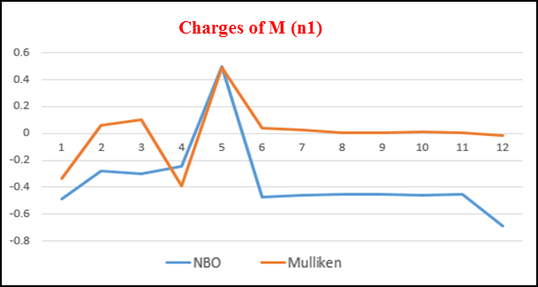 | 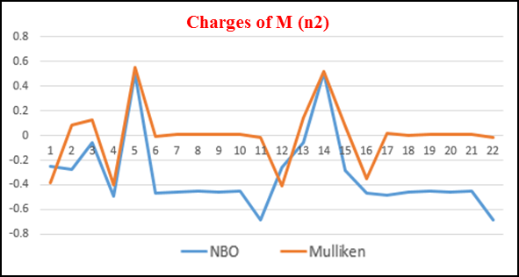
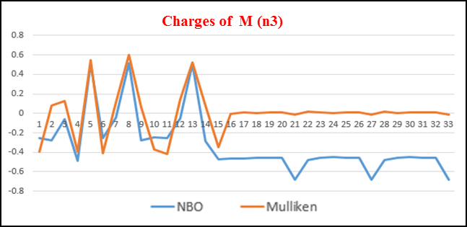 | 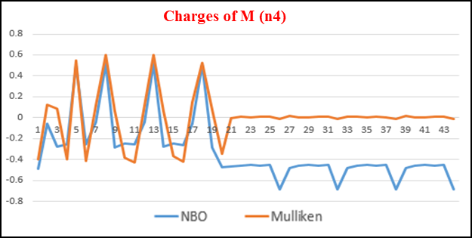
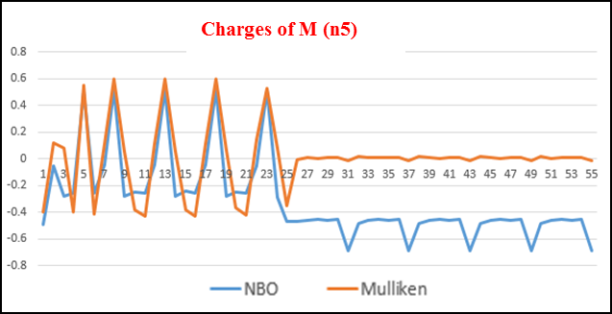 | 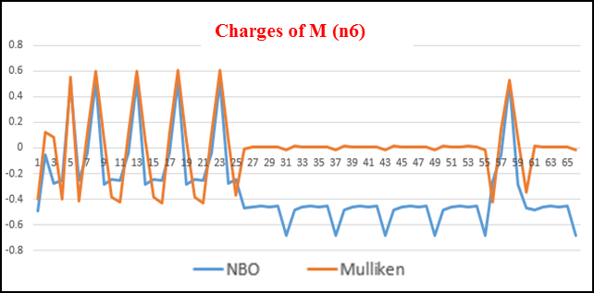
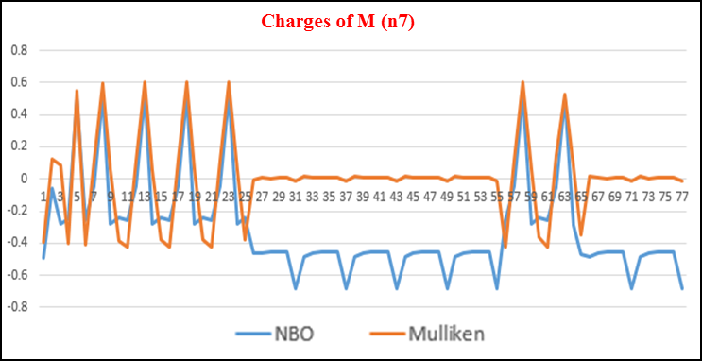 | 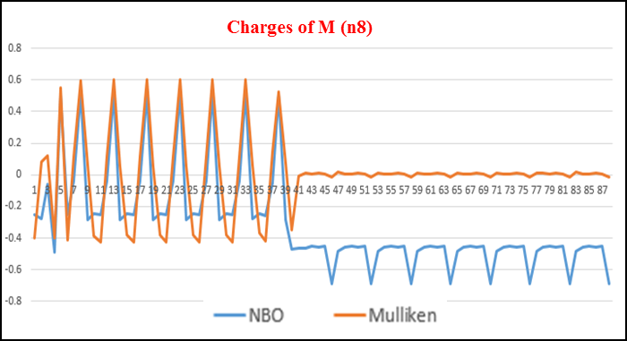
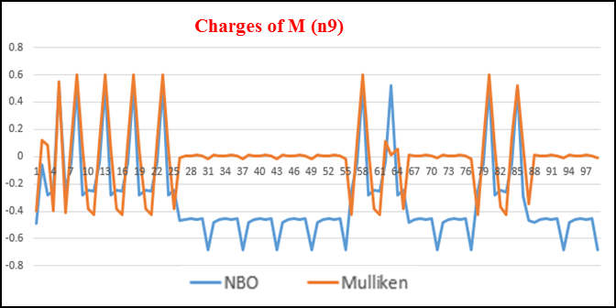 | 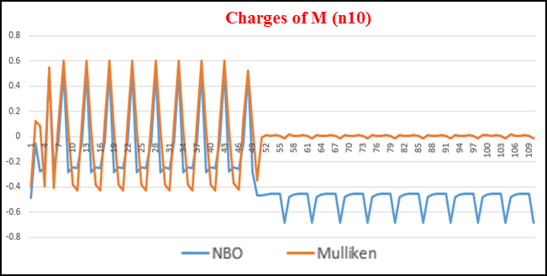

Fig. 3S. NBO and Mulliken charge curves obtained by B3LYP/6-31G (d,P).

