Chalcones and Dihydropyrazole derivatives demonstrate antiproliferative potentials in prostate cancer - A Combined QSAR, Machine Learning, Molecular Docking and ADMETox Investigation
O.E. Oyeneyin^{a*}, B.S. Obadawo^{b}, D.S. Metibemu^{c}, T.O. Owolabi^{d}, A.A. Olanrewaju^{e}, S.M. Orimoloye^{f}, N. Ipinlojuª and O. Olusayo^{g}
a. Theoretical and Computational Chemistry Unit, Department of Chemical Sciences, Adekunle Ajasin University, Akungba-Akoko, Ondo State, Nigeria.
b. Department of Chemistry, University of Toledo, Ohio.
c. Department of Biochemistry, Adekunle Ajasin University, Akungba-Akoko, Ondo State, Nigeria.
d. Department of Physics and Electronics, Adekunle Ajasin University, Akungba-Akoko, Ondo State, Nigeria.
e. Chemistry and Industrial Chemistry Programmes, Bowen University, Iwo, Nigeria.
f. Department of Computer Science, Adekunle Ajasin University, Akungba-Akoko, Ondo State, Nigeria.
g. Department of Physics, Federal University Oye Ekiti, Oye Ekiti, Ekiti State, Nigeria.
*Corresponding author: emmanueltoba90@gmail.com; oluwatoba.oyeneyin@aaua.edu.ng (+2348030417958)

Table S1: Structures of the molecules under investigation
2-16 17-31
MOLECULES | R | MOLECULES | R
2 |  | 17
3 |  | 18
4 |  | 19
5 |  | 20
6 |  | 21
7 |  | 22
8 |  | 23
9 |  | 24
10 |  | 25
11 |  | 26
12 |  | 27
13 |  | 28
14 |  | 29
15 |  | 30
16 |  | 31

Table S2: Generally recommended values of the validation parameters of a built QSAR model
Parameter Definition Recommended value
R² Coefficient of determination ≥0.6
P_{(95%)} Confidence interval at 95% confidence level <0.05
$Q_{cv}^{2}$ Cross validation coefficient ≥0.5
R² -$Q_{cv}^{2}$ Difference between R² and $Q_{cv}^{2}$ <0.3
N_{(ext & test set)} Minimum number of external test set ≥5
$cR_{p}^{2}$ Coefficient of determination for Y-randomization ≥0.5

Table S3: External validation of developed model
Name | ATS1s | VR2_Dzi | SpMax5_Bhm | Mi | $${Y_{exp}}_{test}$$ | $${Y_{pred}}_{test}$$
3 | 94.04115 | 7.094497998 | 3.083744 | 7.410015 | 3.75 | 3.669164
6 | 89.87449 | 9.576671908 | 3.045438 | 7.385456 | 3.85 | 3.752546
7 | 88.70782 | 9.840120491 | 3.046522 | 7.435682 | 4.51 | 4.125395
10 | 136.7634 | 15.13777952 | 3.395406 | 7.490422 | 3.86 | 3.651605
14 | 125.784 | 12.42268676 | 3.395593 | 7.425355 | 3.69 | 3.496997
16 | 124.6934 | 24.20505641 | 3.543003 | 7.416142 | 4.77 | 4.488785
21 | 128.7634 | 11.61007426 | 3.394971 | 7.465871 | 3.87 | 3.584192
24 | 123.0967 | 10.9532925 | 3.394853 | 7.484414 | 3.59 | 3.872006
28 | 91.39506 | 6.727236349 | 3.266787 | 7.352682 | 3.76 | 3.745752

Table S4: Calculation of the predicted R² of developed model
$${Y_{pred}}_{test}-{Y_{exp}}_{test}$$ | $${Y_{pred}}_{test}-{Y_{exp}}_{test}$$ | $${\overline{Y}}_{training}$$ | $${Y_{pred}}_{test}-{\overline{Y}}_{training}$$ |  |  | $${{Y_{pred}}_{test}-{\overline{Y}}_{training}}^{2}$$
-0.08084 | 0.006534 | 3.711 |  | 0.039 | 0.001521
-0.09745 | 0.009497 | 3.711 |  | 0.139 | 0.019321
-0.3846 | 0.147921 | 3.711 |  | 0.799 | 0.638401
-0.20839 | 0.043428 | 3.711 |  | 0.149 | 0.022201
-0.193 | 0.03725 | 3.711 |  | -0.021 | 0.000441
-0.28121 | 0.079082 | 3.711 |  | 1.059 | 1.121481
-0.28581 | 0.081686 | 3.711 |  | 0.159 | 0.025281
0.282006 | 0.079527 | 3.711 |  | -0.121 | 0.014641
-0.01425 | 0.000203 | 3.711 |  | 0.049 | 0.002401
${\sum{\left({Y_{pred}}_{test}-{Y_{exp}}_{test}\right) }}^{2}=$0.485129
${\sum{\left({Y_{pred}}_{test}-{\overline{Y}}_{training}\right)}}^{2}=$1.845689
$R_{Pred}^{2}=1- \frac{0.485129}{1.845689}=$0.737155

Table S5: Pearson’s correlation matrix, VIF and ME of the descriptors used in the built model
Descriptors | ATS1s | VR2_Dzi | SpMax5_Bhm | Mi | VIF | ME
ATS1s | 1 | 0.732712 | 0.711697 | 0.73514 | 11.74599 | -0.08976
VR2_Dzi | 0.732712 | 1 | 0.586512 | 0.251353 | 3.666384 | 0.014118
SpMax5_Bhm | 0.711697 | 0.586512 | 1 | 0.314264 | 2.608657 | 0.130198
Mi | 0.73514 | 0.251353 | 0.314264 | 1 | 4.490817 | 0.945449

Table S6: Comparison of the QSAR model with the ELM Sine and Sig models
S/No | Measured activity (pIC₅₀) | QSAR (pIC₅₀) | %error | ELM-Sine (pIC₅₀) | % error | ELM_Sig  (pIC₅₀) | % error
2 | 3.36 | 3.40 | 1.20 | 3.36 | 0.00 | 3.44 | 2.38
3 | 3.75 | 3.67 | 2.15 | 3.75 | 0.00 | 3.75 | 0.11
4 | 3.41 | 3.64 | 6.79 | 3.84 | 12.61 | 3.73 | 9.47
5 | 3.83 | 3.63 | 5.19 | 3.83 | 0.00 | 3.73 | 2.65
6 | 3.85 | 3.75 | 2.53 | 3.85 | 0.00 | 4.00 | 3.88
7 | 4.51 | 4.13 | 8.53 | 4.51 | 0.00 | 4.46 | 1.14
8 | 3.60 | 3.63 | 0.79 | 3.60 | 0.00 | 3.60 | 0.08
9 | 3.53 | 3.61 | 2.24 | 3.53 | 0.00 | 3.65 | 3.37
10 | 3.86 | 3.65 | 5.40 | 3.86 | 0.00 | 3.76 | 2.48
11 | 3.45 | 3.47 | 0.71 | 3.45 | 0.00 | 3.61 | 4.77
12 | 3.59 | 3.50 | 2.61 | 3.59 | 0.00 | 3.76 | 4.84
13 | 3.68 | 3.70 | 0.56 | 3.68 | 0.00 | 3.66 | 0.45
14 | 3.69 | 3.50 | 5.23 | 3.69 | 0.00 | 3.53 | 4.35
15 | 4.03 | 3.98 | 1.25 | 4.03 | 0.00 | 3.95 | 2.09
16 | 4.77 | 4.49 | 5.90 | 4.77 | 0.00 | 4.74 | 0.72
17 | 3.45 | 3.49 | 1.06 | 3.45 | 0.00 | 3.39 | 1.78
18 | 3.92 | 3.92 | 0.11 | 3.92 | 0.00 | 3.98 | 1.45
19 | 3.49 | 3.60 | 3.25 | 3.49 | 0.00 | 3.64 | 4.28
20 | 3.83 | 3.58 | 6.42 | 3.84 | 0.14 | 3.62 | 5.41
21 | 3.87 | 3.58 | 7.39 | 3.83 | 0.99 | 3.62 | 6.38
22 | 3.58 | 3.64 | 1.70 | 3.54 | 1.17 | 3.60 | 0.62
23 | 3.69 | 3.65 | 1.16 | 3.69 | 0.00 | 3.64 | 1.24
24 | 3.59 | 3.87 | 7.86 | 3.59 | 0.00 | 3.54 | 1.35
25 | 3.88 | 3.79 | 2.21 | 3.88 | 0.00 | 3.60 | 7.19
26 | 3.57 | 3.56 | 0.18 | 3.57 | 0.00 | 3.64 | 2.00
27 | 3.68 | 3.86 | 4.92 | 4.10 | 11.33 | 3.93 | 6.80
28 | 3.76 | 3.75 | 0.38 | 3.76 | 0.00 | 3.88 | 3.07
29 | 3.79 | 3.78 | 0.22 | 3.79 | 0.00 | 3.81 | 0.50
30 | 4.08 | 3.97 | 2.80 | 4.08 | 0.00 | 4.04 | 1.05
31 | 4.50 | 4.53 | 0.57 | 4.69 | 4.27 | 4.25 | 5.59
 | MAPD |  | 3.04 |  | 1.02 |  | 3.05

Table S7: The mean absolute error, root mean-square error and correlation coefficient of the QSAR model with the ELM Sine and Sig models
 | MAE (pIC₅₀) | RMSE (pIC₅₀) | CC
QSAR | 0.12 | 0.16 | 88.87
ELM-Sine | 0.04 | 0.12 | 94.42
ELM-Sig | 0.11 | 0.14 | 89.54

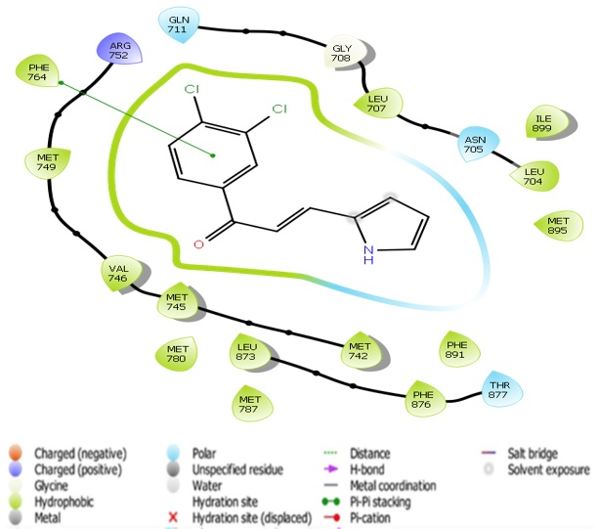
Figure S1: 15 with 2AXA
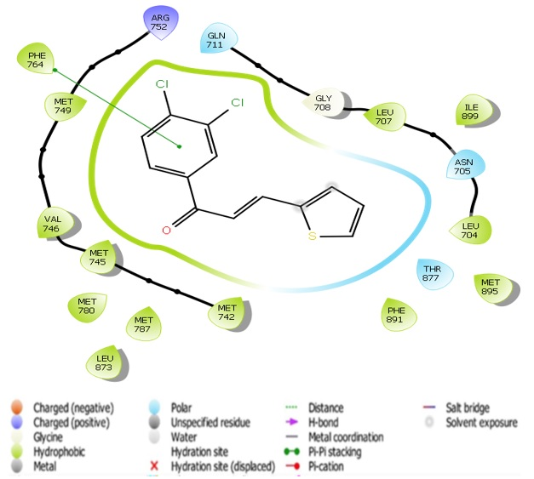
Figure S2: 16 with 2AXA
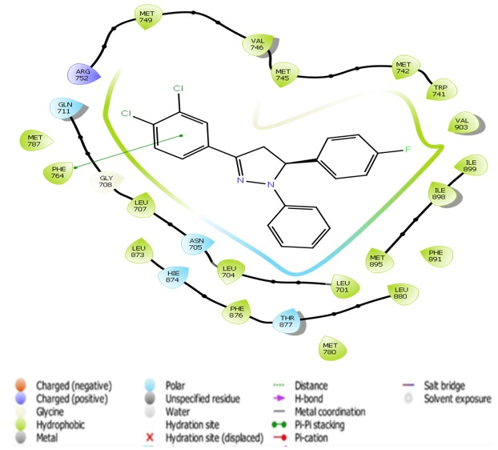
Figure S3: 18 with 2AXA
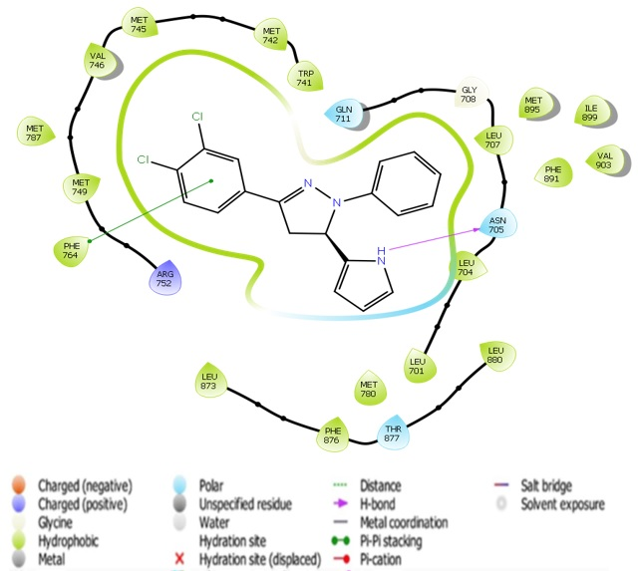
Figure S4: 30 with 2AXA
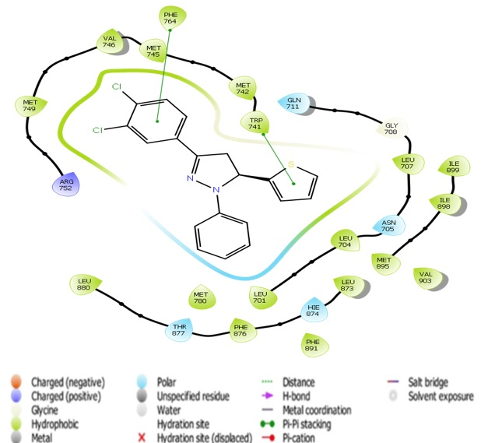
Figure S5: 31 with 2AXA
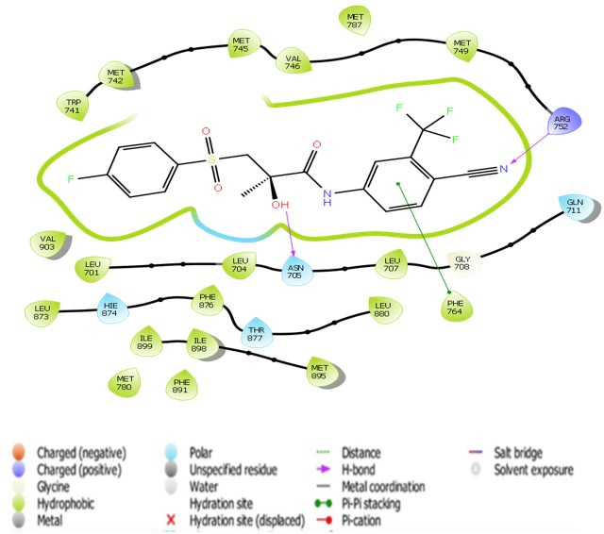
Figure S6: R-bicalutamide with 2AXA

